**ROAD TRAFFIC OFFENCE INFORMATION MANAGEMENT SYSTEM**

**BY**

**NDUGBU LESLIE NNEJI**

**PG/M.SC/12/61724**

BEING A M.SC PROJECT REPORT SUBMITTED IN COMPUTER SCIENCE OF THE UNIVERSITY OF NIGERIA.

**SUPERVISOR: DR. G.A.M IKEKEONWU**

**DEPARTMENT OF COMPUTER SCIENCE**

**FACULTY OF PHYSICAL SCIENCES**

**UNIVERSITY OF NIGERIA, NSUKKA**

**JUNE, 2015**

**ROAD TRAFFIC OFFENCE INFORMATION MANAGEMENT SYSTEM**

**Certification**

I hereby declare that the work presented herein was done by me, and not by a third party. Should I be convicted of having cheated in this work, I shall accept the verdict of the university.

**Leslie Nneji Ndugbu, PG/M.SC/12/61724**

**Approval**

This project report is approved for submission**.**

**Dr. G.A.M Ikekeonwu**

**(**Supervisor)

**Dedication**

This project work is dedicated to God Almighty, His mercies and graces are immeasurable.

**Acknowledgement**

It now gives me great pleasure to express my gratitude to our Lord Jesus Christ for aiding me to accomplish the task He sets before me, and to those who in special measure have aided me in this dissertation.

Special thanks to my supervisor, Dr. G.A.M Ikekeonwu, for his suggestions, advices and guidance. I would like to express my thanks to Prof. F.S Bakpo, the Head, Computer Science Department. The efforts of my indefatigable lecturers in Computer Science Department are most appreciated.

A million thanks go to my family for their moral and financial support most especially: Mrs. Augustina Ngozi Ndugbu, Rev Fr. Kizito Ndugbu, Rev. Fr. Dr. Policarp Ndugbu, Elsie and Stefan.

I will not forget to appreciate my colleagues, who directly or indirectly aided in the completion of this work, thank you all.

**ABSTRACT**

This work is concerned with road traffic offence information management in Nigeria. It focused on trends in road traffic offences information and carried out a critical review of current information and communication and technology compliance state of FRSC with a view to identifying its defects in road traffic offence information management. A system to correct road traffic offence information management failure as identified in the existing system was then proposed. Road traffic offence records and details of current safety measures obtained from FRSC and online in addition to research works, provided the basic data for the study. The system was designed using the object OOAD methodology and implemented using rapid Php IDE on a Windows 7 system, using PHP, HTML,CSS and mySQL technologies and Apache server as the application server. The result showed the high rate of road traffic offence as a result of poor road traffic offence information management and failure to improve on the existing road traffic information management.

**TABLE OF CONTENTS**

Title page .. .. .. .. .... .. .. .. .. .. i

Certification.. .. .. .. .... .. .. .. .. ii

Approval page ... .. . .... ... ... ... ... ... iii

Dedication.. .. .. .. .... .. .. .. .. ... iv

Acknowledgment .. .. .. .. .... .. .. .. . v

Abstract.. .. .. .. .... .. .. .. .. .. .. vi

Table of contents.. .. .. .. .... .. .. .. .. vii-ix

List of figures.. .. .. .. .... .. .. .. .. .. x-xi

List of tables.. .. .. .. .... .. .. .. .. .. xii

**CHAPTER ONE**

**Introduction**

1.1 Background of Study .. .. .. .... .. .. .. 1

1.2 Statement of Problem.. .. .. .. .... .. .. .. 2

1.3 Objective of Study.. .. .. .. .... .. .. .. 3

1.4 Significance of Study .. .. .. .. .. .. .. 3

1.5 Scope of Study.. .. .. .. .... .. .. .. .. 4

1.6 Definition of Terms .. .. .. .. .. .. .. 4

**CHAPTER TWO**

**Literature Review**

2.1Introduction.. .. .. .. .... .. .. .. .. 6

2.2 Theoretical Background.. .. .. .. .... .. .. 6

2.3 Review of Related Literature.. .. .. .. .... .. 11

**CHAPTER THREE**

**Systems Analyses and Design**

3.1 Introduction .. .. .. .. .... .. .. .. .. 23

3.2 Description of the Existing System.. .. .. .. .... 24

3.3 Analysis of Proposed System .. .. .. .. .... .. 25

3.4 Design of the Proposed System.. .. .. .. .... .. 31

3.5 Database Design.. .. .. .. .... .. .. .. 31

**CHAPTER FOUR**

**System Implementation**

4.1 Introduction.. .. .. .. .... .. .. .. .. 46

* 1. Choice of Development Environment.. .. .. .. .... 46

4.3 Implementation Architecture.. .. .. .. .... .. 48

4.4 Software Testing.. .. .. .. .... .. .. .. 49

4.5 Documentation .. .. .. .... .. .. .. .. 49

4.5.1 User Manual.. .. .. .. .... .. .. .. .. 52

**CHAPTER FIVE**

**Summary and Conclusion**

5.1 Summary.. .. .. .. .... .. .. .. .. .. 53

5.3 Recommendations.. .. .. .. .... .. .. .. 60

5.2 Conclusion.. .. .. .... .. .. .. .. .. 61

**References**

Appendix D.. .. .. .. .. .. .. .. .. .. 63

Appendix E .. .. .. .. .. .. .. .. .. .. 71

**LIST OF FIGURES**

Figure 2.1: Records of Road Traffic Crashes (2007-2013). 22

Figure 3.1: Use Case Diagram of Road Traffic Offence

Information Management System 28

Figure 3.2 Sequence Diagram of Road Traffic Offence Information Management System 29

Figure 3.3: Class Diagram of Road Traffic Offence Information

Management System and their Relationships 30

Figure 3.4: System Architecture 33

Figure 3.5: Crime Registration Screen 34

Figure 3.6: Offence Registration Screen 36

Figure 3.7: View Report Screen 36

Figure 3.8: View Offender Detail 38

Figure 3.9 : Ticket Output Form 39

Figure 3.10: Program Procedure Chart 40

Figure 3.11 : Program Flowchart of Road Traffic Offence System 42

Figure 3.12 : Flowchart to Register Offender 42

Figure 3.13: Flowchart to Search Offender 43

Figure 3.14: Flowchart to View Reports 43

Figure 3.15: Flowchart for Settings 44

Figure 3.16: Flowchart to Generate Ticket 45

Figure 4.1: Implementation Architecture 48

Figure 4.2: Home Page Screen Shot 63

Figure 4.3: Admin-Login Page Screen Shot 64

Figure 4.4: Register Crime or Crime Settings Page Screen Shot 65

Figure 4.5: Register Offender Page Screen Shot 66

Figure 4.6: View All Report Page Screen shot 67

Figure 4.7: Offender Detail Page screen shot 68

Figure 4.8: Issue Ticket Page Screen Shot 69

Figure 4.9: Offender Ticket Page Screen Shot 70

Figures 5.1 Prospective users’ assessment 55

**List 0f Tables**

Table 2.1: Showing Road Safety Offences and Corresponding Penalties 18

Table 2.2: Default Speed Limits for Different Roads 20

Table 2.3: Showing the Speed Limits That Apply To Different Vehicles 21

Table 3.1: Ctype.Sql - Crime Information Table 31

Table 3.2: Vehicle and Offender Information Table 32

**CHAPTER ONE**

**INTRODUCTION**

**1.1 Background of Study**

Nigeria ranked as the country with the second largest road network in Africa in 2011.It population density which varies in rural and urban areas (approximately 51.1% and 48.3% respectively) translates to a population-road ratio of 860 persons per square kilometres showing intense traffic pressure on the available road network [1].This pressure contributes to the high road traffic offence mishap in the country. In Nigeria, road transport is the most commonly used by the majority of citizen, as the easiest option in moving goods and travellers. Despite the important role played by road transport, the sector has encountered a number of challenges emanating from poor road traffic offences information management, resulting to incessant road accidents. Road accidents, resulting from careless driving, over-speeding and other road traffic offences have resulted to numerous consequences including deaths, injuries, disabilities and loss of properties, all of which accelerate to poverty in the country. The death of the most productive member exerts a devastating impact to the families, pushing many into poverty with long lasting effect to their children and their community at large [2]. The poor road offence information management situation in Nigeria has reached such an alarming proportion even to the point of sheer frustration and near helplessness. While many developing and developed countries have made concerted efforts to reduce road traffic offence through the adoption of improved management information technology, Nigeria seems to be lagging behind.

Global trends in road transportation have shown that efficient and safe transportation management models are becoming highly dependent on Information and Communications Technologies[3].There is need for technological interventions in reducing road offences and its consequences, road accidents. Road safety is a global concern not only for public health and injury prevention but also to improve efficiency in road traffic management[3].ICTs’ adoption in road traffic offence information management operations will help to achieve the ambition of drastic reduction in road traffic offences and road accidents prevalent in Nigeria.

* 1. **Statement of Problem**

The way and manner motorists use the roads leave much to be desired. Vehicle drivers take delight in driving on wrong lanes and even abuse the right of way rules, thereby creating conflict in the use of traffic, course delay and sometimes accident. This has lead to enormous road traffic offence on our roads particularly in the cities. This is attributable to poor road traffic offence management. Improved computerized Management Information Systems is the fundamental and the bedrock for increase in Information Technology (IT). Because of the importance of the improved information technology (IT), measures are taken to evolve all sectors of the economy into improved Information Technology compliant. The road traffic offence information sector should not be left out, because an increase in the use of improved information management technology has greater advantages, where process of collecting, processing, storage, retrieval and dissemination of road traffic offence information for the purposes of planning, controlling, coordinating and decision making are not in tone with times. The existing system of road traffic offence gives no room for pictorial identification of offenders. Hence wrong person could be accused. The system is decentralized making road traffic offence information manipulation and accessibility of the database difficult. Also the system has no room for pictorial diagram display of the offence committed, as well as the penalty of offence as an evidence to facilitate prosecution. Hence the offender often sees himself as being compelled to accept responsibility.

* 1. **Objective of Study**

As Nigerian road safety agency, FRSC management embraces the use of computers and information technologies in transport infrastructure. As the development and implementation of improved technological systems continue, it is believed that intelligent transport system will provide an increase in capacity, management and productivity of traditional transport infrastructure as well as contribution to achieving of other goals such as improved management in road traffic offence.

This study seeks to design a system that can achieve the following objectives:

* Centralised road traffic offence information databanks where road traffic offence information can be easily accessed by all authorised user.
* Reduce error in offenders’ identification, as lots offenders escape offence due to wrong identification (pictorial identification) during and after documentation which makes prosecution of offenders’ difficulty.
* Displays a pictorial sketch or diagram of an offence committed as clear evidence to offenders’ crime. This can also be tendered in court during prosecution.
  1. **Significance of Study**

Road traffic Information Management System provides road traffic information that is needed to manage road traffic organizations efficiently and effectively. Road traffic information management and the information it generates are generally considered essential components of prudent and reasonable business decisions. With the growth in information technology, the study offers numerous benefits to the Federal Road Safety Commission and other organisations that deal with road traffic offence information management. There are many reasons why a research on the road traffic offence information management system should be made at this time. The chief reasons being that:

* Road traffic offence information management system uses integrated database-stores all road traffic offence information in a single database. This enhances fast, timely and secured accessibility and sharing of road traffic offence reports for the agency’s decision making
* Identifying road traffic offenders with their pictorial images will aid the agency in authentic documentation and avoid prosecuting wrong persons.
* Often times, Offenders deny ever committing a crime they are apprehended for due to absence of diagram sketch/pictorial display showing the crime committed. Displaying offender crime for the offender to see enhance the agency’s credibility and makes FRSC road traffic information reports reliable.

**1.5 Scope of the Study**

The study shall concentrate on importance of information and communication technology to road traffic safety management discussions as well as research works on attempts to improve on road safety management will be reviewed. It shall examine the state of FRSC and then propose a system to arrest the identified lapses militating against road traffic offence information management in Nigeria.

* 1. **Definition of terms**

Terms are contextual. Words have the tendency to derive their meanings within the context of their use. This section of the chapter is devoted to the definition of road traffic computer terms used in this dissertation. This is important because road traffic information management terms are defined differently by different researchers, so specific definition of the terms as they apply to this study is therefore necessary to enable the readers to fully understand the meaning of the study and its proper significance.

**Road Traffic Offence**

This phrase refers to any act that causes or liable to cause violation of road traffic rules and regulations. Road traffic offence is an action taken or action not taken that violates road safety rules and regulation. For instance not reporting a road traffic accident is a road traffic offence.

**Information Technology**

This term also called information system refers to a set of interrelated components that work together to collect, retrieve, process, store and disseminate information for the purpose of facilitating planning, control, co-ordinating and decision making. It usually includes hardware, software, people, communication systems, and data [4].

**Information and Communication Technology**

This refers to the fusion of Telecommunications, Electronics and Computer Information Systems used to retrieve, analyze, store, process, transmit, secure and intelligently interpret digital data either in storage or in transit [5]

**Intelligent Transport Systems**

This refers to wide area of information based on wireless technology combined into infrastructure of transport system and the vehicle itself, these systems help in controlling and managing of traffic flows, reducing of traffic, finding alternative routes, saving of the environment as well as saving time [6].

**CHAPTER TWO**

**LITERATURE REVIEW**

**2.1 Introduction**

In this chapter, the concepts and technologies used in the work and how they are used are explained. Also in this chapter, the works of other researchers who have worked on related works were discussed under review of related literature, to aid the researcher in solving the identified problems.

**2.2 Theoretical Background**

The technologies used in this application are web technologies: HTML, CSS, PHP, JavaScript and relational database technology (mySQL).

1.The main building technology of the application, Road Traffic Offence Information Management System is the HTML, The HTML is the markup language used to describe and define the content of webpage. The HTML is used to tell the browser what to display on the page, like appearance of text such as bold or italics text and also used to specify images. The main HTML features used were form and Cascading Style Sheet. The form was used to collect LOGIN data-username and password-from a user and a submit button (Login) to send the collected data to a web document to act on the data. HTML code used to creat form :

<form id="form1" name="form1" method="post" action="index.php?fm=1">

<p>

<label><strong>Username</strong>

<input type="text" name="txt1" class="inputText" id="txt1" />

</label>

</p>

<p>

<label><strong>Password</strong>

<input type="password" name="txt2" class="inputText" id="txt2" />

</label>

</p>

<label>

<input type="checkbox" name="checkbox" id="checkbox" />

Remember me</label>

<input name="button" type="submit" class="black_button" id="button" value="Submit" />

</form>

2.The styling of the application was done using CSS. This include the

* The Layout
* Link Styling
* Colouring
* Picture Alignment
* Menu Building

Cascading Style Sheets (CSS) is a style sheet language used to describe the look and formatting of the document written in HTML. Presentation of information to the user by the browser was controlled by means of Cascading Style Sheet. Cascading Style Sheet is a cornerstone specification of the web and was used in the application to describe their presentation. CSS was designed to enable the separation of document content from document presentation, including elements such as the layout, colours, and fonts. This separation can improve content accessibility, provide more flexibility and control in the specification of presentation characteristics, enable multiple pages to share formatting, and reduce complexity and repetition in the structural content (such as by allowing for tableless web design). It avoids those portions of markup that would specify presentation by instead, providing that information in a separate file. For each relevant HTML element (identified by tags), it provides a list of formatting instructions. For example, it might say (in CSS syntax), "All heading 1 elements should be bold." Therefore, no formatting markup such as bold tags () is needed within the content; what is needed is simply semantic markup saying, "this text is a level 1 heading.".The HTML code used to create menus and submenus:

<div id="menu">

<ul class="group" id="menu_group_main">

<li class="item first" id="one"><a href="welcome.php" class="main"><span class="outer"><span class="inner home">Home</span></span></a></li>

<li class="item middle" id="two"><a href="ticket.php" class="main"><span class="outer"><span class="inner content">Issue Ticket</span></span></a></li>

<li class="item middle" id="three"><a href="report.php"><span class="outer"><span class="inner reports png">View Reports</span></span></a></li>

<li class="item middle" id="four"><a href="view.php" class="main"><span class="outer"><span class="inner users">Search Offender</span></span></a></li>

<li class="item middle" id="five"><a href="#" class="main current"><span class="outer"><span class="inner media_library">Register Offender</span></span></a></li>

<li class="item last" id="eight"><a href="settings.php" class="main"><span class="outer"><span class="inner settings">Settings</span></span></a></li>

</ul>

</div>

3.JavaScript is combined with HTML and CSS to create a dynamic HTML pages. JavaScript is commonly used on the internet to create web pages that respond to user actions, like when user moves a mouse pointer over an image or clicks a form button. JavaScript was used for the client side scripting and security, it was also integrated with jquery and ajax to create Modal Windows used in the application like:

Generating Print preview display

To ensure the registrant does not submit empty forms

To ensure that the information requested is what the user enters using the JAVASCRIPT regular expression to match the data submitted.

JavaScript ,HTML code:

<script id="source" language="javascript" type="text/javascript" src="js/graphs.js"></script>

<script type="text/javascript" src="../tb/tinybox.js"></script>

<script type="text/javascript" src="../../ajax.googleapis.com/ajax/libs/jquery/1.3.2/jquery.min.js"></script>

<script type="text/javascript" src="js/blend/jquery.blend.js"></script>

<script type="text/javascript" src="js/ui.core.js"></script>

<script type="text/javascript" src="js/ui.sortable.js"></script>

<script type="text/javascript" src="js/ui.dialog.js"></script>

<script type="text/javascript" src="js/ui.datepicker.js"></script>

<script type="text/javascript" src="js/effects.js"></script>

<script type="text/javascript" src="js/flot/jquery.flot.pack.js"></script>

4.The connection to the database was done using the scripting language PHP. In the project, PHP was used for:

* Handling data validation
* Editing, Deleting information in the database
* Database connectivity
* Managing Scripting Functionality
* Generating Dynamic content in the application like displaying the information of traffic offenders in the application
* Searching and fetching information from the database and sorting them accordingly like the periodic display of traffic defaulters in the application.

PHP is a server-side scripting language designed for web development but also used as a general-purpose programming language.PHP is used in the application to access database and provide server-side form, because it is closely integrated with mySQL database, open source, light weight and does not consume much server resources to render page.

PHP syntax:

<?php

Code

?>

PHP code can be simply mixed with HTML code, or it can be used in combination with various templating engines and web frameworks. PHP code is usually processed by a PHP interpreter, which is usually implemented as a web server's native module or a Common Gateway Interface (CGI) executable. After the PHP code is interpreted and executed, the web server sends resulting output to its client, usually in form of a part of the generated web page – for example, PHP code was used to generate a web page's HTML code, an image, and some other data. PHP has also evolved to include a command-line interface (CLI) capability and can be used in standalone graphical applications. PHP is contained within the body of an HTML page and runs on window-based servers with an installed interpreter.

5.The database used for storing information in this project application is MYSQL.

Working together with PHP is mySQL, most widely used open-source relational database management system (RDBMS). The SQL phrase stands for Structured Query Language.. MySQL is a popular choice of database for use in web applications, and is a central component of the widely used LAMP open source web application software stack (and other 'AMP' stacks). LAMP is an acronym for Linux, Apache, MySQL, Perl/PHP/Python. Both php and mySQL instructions are used in this application are used together in the code to open the database, establish connection between it and the HTML code to insert data, retrieve data, delete data etc

**2.3 Review of Related Literature**

A report of the United Nations on Road Safety shows that 1.3 million people die each year in traffic related accidents and another 20 million to 50 million people are injured mainly in developing countries around the world [7]. Statistics show that while developing countries own only 32% of the world’s vehicles, they account for 75% of annual accident fatalities [2]. Information and Communication Technology in road safety technologies is usually applied through the collation, storage, analysis and processing of vital electronic data including: weather readings, accident location co-ordinates, precise remote traffic light adjustment, warning thresholds, speed chart, driver alertness, and other data attributes [5].Use of Information and Communication Technology to facilitate safe transportation, promote easier dissemination of road traffic information, ensure comfortable manipulation of road machineries, improve the efficiency of road traffic signs/alerts, promote mass awareness of safety consciousness, facilitate more effective rescue operations and improve the monitoring of the changing conditions of roads and machineries is therefore a necessity. Management cannot plan, deploy, and control resources without essential information [8]. The road traffic agencies need such information to judge whether the road traffic agencies is using resources efficiently and providing road users with value-for-money. A comprehensive management Information System (MIS) normally consists of a computerized road management system for planning, programming, budgeting and preparation of road works [8]. Management information system used by the average road agency consists of a set of established and documented procedures that generate and evaluate alternative ways of operating, maintaining, improving, and extending the road network [8]. It will generally show the condition of the road network and its use (traffic volumes and loading), and can be used to explore the impact of management interventions on current and future service levels. It can also be used to generate information on the physical and financial performance of the road network. The management information system provides a framework for making decisions on a number of issues usually handled by different divisions within the road agency [8]. Information and Communication Technology (ICT) has been effective in improving road safety in developed countries and some developing countries through prudent management of road traffic offences , In Bangalore for instance, in the author observed that, in 2007, before the introduction of technology, the city’s Police had booked nearly 1.4 million cases of traffic offence, which had risen to 3.3 million in 2010,at the introduction of information technology, the number of fatal accidents were brought down from 957 in 2007 to 816 in 2010,non-fatal accidents have come down from 6,591 to 5,343,through improved compliance and managing traffic better[9].

International Telecommunications Union (ITU) the United Nation Agency in charge of Information and Communication Technology (ICT) has been assisting, through the aid of Intelligent Transportation Systems (ITS), since these are systems in which Information and Communication Technologies (ICTs) are applied in order to increase road safety management and effectiveness of transportation systems[7].Among these systems is the Driver Assistance System (DAS) that applies specific electronic components in a vehicle that help the driver with the task of driving. For example, a vehicle with DAS has a Global Positioning System (GPS) that makes use of satellites which can provide up- to- date traffic information. Drowsiness and blind spot detection; night-vision and lane change assistance; and a collision avoidance system that uses in-car radars can be experienced with the use of DAS [10]. Speed management cameras can be used to prevent drivers from speeding. These infrared cameras can find out precisely the speed at which a vehicle is moving and are connected to a computer to identify a vehicle’s registration number. Road worthiness of vehicles can be examined using computer technology, for instance to check the braking system and seat belts. Special software is then used to find out precisely if the data is in accordance with law making requirements of the country [10]. Laser scanners, cameras or digital photographs can be used to identify potholes, cracks and defective bridges, when conducting road safety inspections. [11] affirmed that intelligent car safety systems reduce the proportion of accidents attributed to human factor (95%). The systems make use of ICT to provide solutions for improving road safety especially before a crash occurs. The author observed that ICT used in smart cars are designed to ensure safe speed, lane support, pedestrian protection, improved vision, driver monitoring and intersection safety. According to the author, the two major contributions of intelligent car safety system are, they prevent collisions during lane changes or lane departure and provide vehicles with an automatic emergency call system, [eCall](http://europa.eu/legislation_summaries/information_society/other_policies/l31103a_en.htm). Emergency call (eCall) is a communication system that assigns a unique telephone number (often toll-free) exclusively for reporting emergencies and distress conditions eCall can also be connected into web-based road safety portals to give it wider access beyond the bounds of the cellular network’s coverage area [5]. eCall system could be made to start working either manually by the people in the car, or automatically by sensors within the vehicle. Upon activation, eCall connects the vehicle's occupants to the nearest Public Safety Answering Point (PSAP). eCall, according to the author, ensures a faster rescue time and a higher survival probability, during emergency

Speed Alert systems warns the driver when he is driving at a speed that exceeds the legal speed limit or self-imposed speed limit, the driver is then able to reduce his speed leading to a decrease in road fatalities. Autonomous cars are also now very common. These are robotic cars which require no human input due to sensors inside and outside the vehicle [10].

Intelligent Traffic Systems (ITS) uses ICTs to manage driving, traffic, and all factors that are important in one way or the other to transport safety design and education. ITS systems could be in-vehicle systems, or external infrastructure support. Interfacing road infrastructure hardware with in-vehicle warning and control systems is another road safety groundbreaking technology [7]. Intelligent Transport Systems differ in technologies applied, from basic management systems like car navigation, traffic signal control systems, variable message signs, automatic number plate recognition or speed cameras to monitor applications. Example is the Closed Circuit TV (CCTV) systems and other advanced applications that combine live data and feedback from sources, such as parking guidance and information systems [8].

[5] asserts that among the Intelligent Transport Technologies include

* **IP-based CCTV and surveillance cameras:**

Traffic Closed Circuit TV (CCTV) systems combined together with surveillance cameras are video-based vehicle/motion detection systems used for remote surveillance of traffic situations to track offenders, to build usable traffic data and to provide an archive for future road transport enhancements. Specifically the use of Internet Protocol (IP) based CCTV systems and surveillance cameras introduce a lot of interactivity in the remote manipulation of the cameras, and also ease the task of searching for specific reference scenes.

* **Speed monitors:**

Speed sensors are two-way electronic communication devices that estimate the relative speed of road vehicles, and compare it with the stipulated speed limits. In advanced implementations, any speed over-shoot beyond the stated limit triggers a zoom-in from the nearest camera and the vehicle is instantly traced while video capture/recording is automatically activated.

* **Web-based road safety portals:**

The World Wide Web (www), also called the web. The web represents the huge volume of resources, multimedia content and data bank which are limitlessly accessible using client browsers, and other web applications through networking technologies. Road safety web portals enable the continuous publication of interactive resources which can equip stakeholders with vital statistics concerning the true nature of traffic conditions, accident spots, nearby health institutions, and real-time distress calls.

* **Automated Emergency Call System (eCall):**

The eCall is a communication system that assigns a unique telephone number (often toll-free) exclusively for reporting emergencies and distress conditions. ecall can also be integrated into web-based road safety portals to give it wider access beyond the bounds of the cellular network’s coverage area.

* **Point to point communications (PPC):**

Enables road safety officials to use high-speed radio systems to communicate between multiple locations and for vehicle-to-vehicle driver communications. Radio frequency (RF) channels, allocated by the telecoms regulatory body (For instance, the Nigeria Communications Commission NCC) are meant to be used to communicate from one location to the other among mobile road users.

* **Wireless networks (Wifi and WiMAX):**

Hand-held, portable electronic devices influences existing cellular and private wireless networks to provide a one-touch access to traffic data, weather condition reports, transport news. The efficiency of the systems builds on the prevalence of their data which updates in real-time and fully accessible from web applications (web apps) within contemporary smartphones, blackberries, android, iPad and other handheld electronic devices.

* **Car navigation systems (Driver support systems):**

Car navigation systems are a range of intelligent systems that warn the driver based on information received from a central database or other environmental interpretations of what may appear to be adverse condition that may lead to a crisis if no precautionary measures are taken. Such warnings may include bad weather, obstructed lanes, speed limits, slippery lane, etc.

ICT allows road users and vehicles to be managed based on real-time road status information [12]. In the work, Role of ICT in Monitoring and Solving Traffic Issues, [6] proposed a system that uses the power of smart phones in delivering real time information pertaining to the events happening on the major roads. The application can synchronize web application with the mobile application, both of which share the same database. The important thing is that user can send his information through application about conditions on the road where he is and to choose event, which is the reason he is in the crowed (road works, traffic accidents). Users use mobile and web application for monitoring and informing about traffic problems that they meet .In addition to that, the application is equipped with map to locate the location with the reported road incident. The introduction of ICT into traffic systems will contribute to reducing of gas emissions, traffic accidents, save the time and money [6]. In 2013, [13] proposed a GPS based system for tracking in real time the school transportation to avoid over-speeding and reckless driving. The system is modelled to track school buses which are fitted with GPS tracker of which send the information to school via GSM network and monitoring station. The proposed approach provides an overview of the GPS technology adoption and how it can be employed in over speeding detections with auto email and short messaging (SMS) alerts [13]. In 2014, [2] proposed a model that constantly track buses in real time and central database. The model is capable of promptly popping up warning messages in case of over-speeding for appropriate action. The analysed data from the central database could be used as the evidence in case of traffic case prosecution. The system allows for easy tracking of drivers with a habit of over-speeding and therefore appropriate disciplinary action could be taken against them, such as ceasing of their driving license. The proposed system makes use of the potential of Global Positioning System (GPS), Global Positioning Satellites and Global System for Mobile communications (GSM) Technology in delivering its services [2].No measures to capture offenders’ pictures for proper offender’s identification. Also there is need to have a singled integrated road traffic offence information database for prudent road traffic offence information management. To facilitate prosecution, a system that displays offender crime sketch diagram/picture has to be developed.

Thousands of motorists are still being apprehended daily and sanctioned for various traffic offences on the roads, notwithstanding the laws and regulations put in place to curb the increasing rate of traffic offences and violations on the Nigerian highways [8]. This is as a result inadequate information and communication technology interventions and poor road traffic offence information management.

Federal Road Safety Corps (FRSC), the regulatory body in-charge of road safety in the country stipulates penalty for offence committed to deter offenders and reduce to the minimum, road traffic offence in the country.

Table 2.1: **Showing Road Safety Offences and Corresponding Penalties**

|  |  |  |  |  |  |
| --- | --- | --- | --- | --- | --- |
| **S/N** | **Type Of Offences Committed** | **Code** | **Points** | **Penalty** | **Category** |
| 1 | Assaulting Marshal On Duty | AMD | 10 | #10,000 | 2 |
| 2 | Attempting To Corrupt Marshal On Duty | ACS | 10 | #10,000 | 2 |
| 3 | Caution Sign Violation | CSV | 3 | #3,000 | 3 |
| 4 | Construction Area Speed Limit Violation | CAV | 3 | #3,000 | 1 |
| 5 | Dangerous Driving | DGD | 10 | #50,000 | 1 |
| 6 | Do Not Move Violation | DNM | 2 | #2,000 | 2 |
| 7 | Driver’s Licence Violation | DLV | 10 | #10,000 | 2 |
| 8 | Driving Under Alcohol/Drug Influence | DUI | 5 | #5,000 | 2 |
| 9 | Driving With Worn-Out Tyre | TYV | 3 | #3,000 | 1 |
| 10 | Driving With Expired/Without Spare Tyre | EWT | 2 | #2,000 | 3 |
| 11 | Excessive Smoke Emission | ESE | 5 | #5,000 | 1 |
| 12 | Failure To Cover Unstable Materials | FCM | 5 | #5,000 | 1 |
| 13 | Failure To Fix Red Flag On Projected Load | FFF | 3 | #3,000 | 1 |
| 14 | Failure To Move Over | FMO | 3 | #3,000 | 1 |
| 15 | Failure To Report Road Crash | FRC | 10 | #20,000 | 1 |
| 16 | Fire Extinguisher Violation | FEV | 3 | #3,000 | 3 |
| 17 | Inadequate Construction Warning Sign | ICW | - | #50,000 | 1 |
| 18 | Light/Sign Violation | LSV | 2 | #2,000 | 2 |
| 19 | Operating Mechanically Deficient Vehicle | MDV | 5 | #5,000 | 1 |
| 20 | Obstructing Marshal On Duty | OMD | 3 | #3,000 | 2 |
| 21 | Operating A Vehicle With Forged Documents | OFD | 10 | #20,000 | 2 |
| 22 | Overloading | OVL | 10 | #10,000 | 1 |
| 23 | Passengers’ Manifest Violation | PMV | 10 | #10,000 | 2 |
| 24 | Riding Motorcycle Without Using Crash Helmet | RMH | 2 | #2,000 | 1 |
| 25 | Road Obstruction | ROB | 5 | #5,000 | 1 |
| 26 | Road Marking Violation | RMV | 5 | #5,000 | 1 |
| 27 | Route Violation | RTV | 10 | #10,000 | 1 |
| 28 | Seat Belt Use Violation | SUV | 5 | #5,000 | 1 |
| 29 | Speed Limit Violation | SLV | 5 | #5,000 | 1 |
| 30 | Unauthorized Removal/Tampering With Road Sign | UTS | 5 | #5,000 | 1 |
| 31 | Under Age Driving/Riding | UDR | - | #10,000 | 1 |
| 32 | Use Of Phone While Driving | UPD | 4 | #4,000 | 1 |
| 33 | Vehicle Licence Violation | VLV | 3 | #3,000 | 2 |
| 34 | Number Plate Violation | NPV | 3 | #3,000 | 1 |
| 35 | Vehicle Windshield Violation | VWV | 2 | #3,000 | 1 |
| 36 | Wrongful Overtaking | WOV | 3 | #3,000 | 1 |

Source: http://frsc.gov.ng/offences-and-penalties[14].

The table below shows default speed limits for different roads and for different Vehicles, under the Road Traffic Act 2004 [15].

Table 2.2: **Default Speed Limits for Different Roads**

|  |  |
| --- | --- |
| **TYPE OF ROAD** | **SPEED LIMIT** |
| Motorway | 120km/h |
| National roads (Primary and Secondary) | 100km/h |
| Non-National roads (regional and local) | 80km/h |
| Road in built-up areas(cities and towns) | 50km/h |

Table 2.3: **Showing the Speed Limits That Apply To Different Vehicles[15]**

|  |  |
| --- | --- |
| VEHICLE SPEED LIMIT | TYPE OF VEHICLE TO WHICH IT APPLIES |
| 65km/h (On all roads) | A single or double deck bus or coach designed for carrying standing passengers. |
| 80km/h (on all road) | A goods vehicle with a design gross vehicle weight of more than 3,500 kilograms. |
| 80km/h (on all roads) | Any vehicle towing trailer, caravan, horsebox or other attachment. |
| 80km/h (on all roads except motorways or dual carriage ways) | A single or double deck bus or coach that is not designed for carrying standing passengers. |
| 100km/h (on all motorways or dual carriageways where no lower limit is in place) | A single or double deck bus or coach that is not designed for carrying standing passengers. |

According to FRSC 2013 records, speed limit violation (SLV) was the major causative factor of crashes which accounted for 32% of all crashes recorded in 2013,totalling 13,583 crashes (A chart illustrating road traffic crashes as a result road traffic offence in Nigeria from 2007-2013 [16].

Figure 2.1: **Records of Road Traffic Crashes (2007-2013).**

Source: 2013: A Defining Year for Federal Road Safety Corps: Going Digital[16].

According to the road traffic crashes (2007-2013) chart above, about 8,300 road traffic crashes were recorded in the year 2007,while in the year 2008,about 11,500 road traffic crashes were recorded.10,800 road traffic crashes were recorded in the year 2009,while in 2010 a total of about 11,500 road traffic crashes were recorded. In 2011, 13000 road traffic crashes were recorded, while about 13100 road traffic crashes were recorded in 2012.In 2013, about 13900 road traffic crashes were recorded by the FRSC in Nigeria.

**CHAPTER THREE**

**SYSTEMS ANALYSES AND DESIGN**

#### 3.1 Introduction

System development can generally be thought of as having two major components: system analysis and system design. System design is the process of planning a new business system or one to replace an existing system. Before this can be done, we must thoroughly understand the old system and determine how computer and software can be used to make the operation effective. System analysis and Design refers to the process of examining business situation with the intent of improving it through better procedures and methods. System analysis and Design relates to shaping organisations, improving performance and achieving objectives for profitability and growth. The emphasis is on system in action, the relationship among subsystem and their contribution to meeting a common goal.

**Methodology**

This study relied on information obtained from secondary sources especially online materials, Newspapers and documents of relevant agencies like the Federal Road Safety Corps. From these documents required information was obtained on the performance, road traffic crashes records, operational activities and strategies of the corps, enforceable laws and regulation including safety offence and their penalties and its data management system.

The author also examined reports, academic research papers, articles and newspaper reports on essence of information and communication technology on road safety. The obtained information enables the critical review of current state of FRSC in information and communication technology compliance measures.

Object Oriented Analysis and Design (OOAD) methodology was used during the software development. Object Oriented Analysis and Design methodology is a software engineering approach that modules a system as a group of interacting object. OOAD models are pictures that illustrate the system’s objects from various perspectives such as structures and behaviours. Two stages are involved in the approach; Object Oriented Analysis and Object Oriented Design. Unified Modelling Language (UML) notation is the design tool used for modelling in this research.UML used in the research includes: Use Case diagrams, Sequence diagrams and Class diagrams.

**3.1 Description of the Existing System**

Nigeria’s lead road safety agency, the FRSC in 2013 through the use of o electronic reporting system by the launch of three online reporting portals:

* e-Dashboard: The dashboard reports on a weekly basis, all activities of the corps from field commands (units, sectors and zonal commands) to the Headquarters, providing real time dynamic management information system based operation system and providing decision makers with visibility and data.
* e-ticketing: The Corps initiated an e-Ticketing platform which enhances enforcement capacity. Ticketing enabled online verification of drivers and Vehicles using new Drivers License or Number Plates.
* FRSC Intranet: The corps utilised social networks such as Facebook, Twitter, and YouTube accounts to communicate its activities to the public updating information on an hourly basis

These portals enabled electronic transmission of situation reports, weekly, monthly and quarterly reports from field commands to the National Headquarters, Abuja [16].

**Merits of the existing system**

* There is prompt reportage of situation reports from FRSC field commands, as situation reports are transmitted on weekly, monthly and quarterly basis.
* The system utilizes social media networks like Facebook, Twitter and YouTube accounts to communicate its activities to the public. Updating information on hourly basis.
* The system enables online verification of drivers and vehicles using new Drivers license or Number Plates made possible through e-ticketing process.

**Demerits of the Existing System**

* The system as the system gives no room for pictorial identification of offenders. Hence wrong person could be accused.
* The system is decentralized making road traffic offence information manipulation and accessibility of the database difficult.
* The Manual system has no room for pictorial diagram display of the offence committed, as well as the penalty of offence as an evidence to facilitate prosecution. Hence the offender often sees himself as being compelled to accept responsibility.
  1. **Analysis of Proposed System.**

The proposed system is web-based application that captures offence information in real time and updates the central database. The system will be capable of identifying offenders using their pictures. The system can generate offenders’ ticket showing a pictorial display of the type offence committed and the penalty for the crime, as well as directing the offender where to pay for the offence committed. Before sending offenders’ information to the database, the system allows the offender to accept his offence without being compelled to do so. Analysed information from the central database could then be used as the evidence in case of traffic case prosecution

The new system when designed will reduce the problem associated with existing system. The road traffic offence information management system as a computer based information system involves the collection, processing, storage, retrieval and dissemination of road traffic offence information for the purposes of planning, controlling, coordinating and decision making based on the improved technology.

* Road traffic offence information management system provides for security and protection of road traffic offence information to ensure information confidentiality. Only staff with the right password could access the centralized database.
* The road traffic offence information management system increases productivity by guaranteeing timely and less error prone road traffic information, as real time road traffic information management
* There is a centralized road traffic offence information database for easy access in road traffic offence information management system to reducing duplication and data redundancy associated with decentralized database.
* The road traffic offence information management system captures offenders’ picture for easier and clarity in offenders’ identification.
* We are pragmatic beings, people who believe more in what they could see and touch. In a road traffic offence information management system, there is display of pictorial diagram of the offence committed, as well as the penalty of offence as an evidence to facilitate prosecution

**Demerits of the Proposed System**

No system is without deficiencies, road traffic offence information management system has two areas not covered:

* To capture road traffic offence information from the scene of offence, the system uses the aids of the field staff, rather than Global Positioning Satellites technology
* Registration of the offenders’ information cannot be done using mobile devices; therefore registration can only be done in FRSC offices, using computer system with the road traffic offence information system application.

**Use Case Diagrams**

Use case diagrams are used during requirements collection and analysis as a graphical means of representing the functional requirements of the system. Use cases are developed during requirements collection and are further refined and corrected as they are reviewed (by stakeholders) during analysis.

Admin (Staff)

Offender

Figure 3.1**:** Use Case Diagram of Road Traffic Offence Information Management System

**Sequence Diagrams**

A sequence diagrams are used in the analysis and design phase. Sequential diagram shows how messages are sent and received between classes of a given use case, and the exact timing of those messages. The sequence diagram for Road Traffic Offence Information Management System:

ShowScreen()

EnterPword()

ClickOnRegOff()

ClickOnViewOffenders()

Enter LicenceNumberofOffender()

ClickOnSettings()

EnterLicenceNumberofOffender()

RTO System

InitialScreen

Dashboard

Reg.Offenceseee

V.Offencess

S.Offences

Settingsss

G.Ticket

I I I I I I I

I I I I I I I

I I I I I I I

I I I I I I I

I I I I I I I

I I I I I I I

I I I I I I I

I I I I I I I

I I I I I I I

Figure 3.2Sequence Diagram of Road Traffic Offence Information Management System

**Class Diagram**

The class diagram describes the types of objects in a system and the various kinds of static relationships that exist among them. In UML, a class is represented by a rectangle with one or more horizontal compartments. The upper compartment holds the name of the class. The name of the class is the only required field in a class diagram. By convention, the class name starts with a capital letter. The (optional) centre compartment of the class rectangle holds the list of the class attributes/data members, and the (optional) lower compartment holds the list of operations/methods.

CLASS: Admin (Staff)

Id: TEXT

Password: TEXT

+Create Account ()

+Update ()

+Search ()

+Delete ()

+View ()

CLASS: Offender

Oname: TEXT

Oaddress: TEXT

Odate: DATE

Openalty: TEXT

Opassport: TEXT

OcrimePix: TEXT

Password: TEXT

+View ()

+Create Account

+Update

+Search

+Delete

+View

1  **\* \***

*

*

Figure 3.3**:** Class Diagram of Road Traffic Offence Information Management System and their Relationships

**Note:**

**1------------------------\*** One---many---relation.

**3.3 Design of the Proposed System**

**Database Design**

The relational database model was used to design the database. The relational database server used to create the database is mySQL.

Table 3.1**: Ctype.Sql - Crime Information Table**

|  |  |  |  |
| --- | --- | --- | --- |
| **Field Name** | **Description** | **Character Length** | **Data Type** |
| Id | Identification | 2 | Integer |
| Name | Crime Name | 30 | Text |
| Code | Crime Code | 5 | Text |
| Point | Crime Point | 2 | Integer |
| Penalty | Crime Amount | 10 | String |
| Crimepix | Crime Picture | 250 | Text |
|  |  |  |  |

Table 3.2**: Vehicle and Offender Information Table**

|  |  |  |  |
| --- | --- | --- | --- |
| **Field Name** | **Description** | **Character Length** | **Data Type** |
| Id | Identification | 5 | Integer |
| Vowner | Vehicle Owner | 30 | Text |
| Vname | Vehicle Name | 30 | Text |
| Vmake | Vehicle Make | 30 | Text |
| Vmodel | Vehicle Model | 30 | Text |
| Vtype | Vehicle Type | 30 | Text |
| Vchasis | Vehicle Chasis | 10 | Integer |
| Vinsurance | Vehicle Insurance | 10 | Integer |
| Vstateofp | Vehicle State Of Purchase | 30 | Text |
| Ctype | Crime Type | 30 | Text |
| Cdate | Crime Date | 30 | Text |
| Cplace | Crime Place | 30 | Text |
| Croute | Crime Route | 30 | Text |
| Oname | Owner’s Name | 30 | Text |
| Address | Owner’s Address | V | Text |
| Odate | Date | 30 | Date |
| Penalty | Penalty | 50 | Text |
| Oocc | Assulted Official | 30 | Text |
| Opassport | Offender’s Passport | 200 | Text |
| Crimepix | Crime Picture | 200 | Text |

**System Architecture**

The architecture of the system design is 3-tier. The tiers are presentation tier, middle tier and data tier. The presentation tier is the user interface and it is designed using HTML. The middle tier connects the presentation tier and data tier together. The middle tier is also called application tier or business logic. The middle tier was designed using PHP and it runs on the server. The data tier is the part of the system that is responsible for storing data (database). The database management system used for developing this system is mySQL database server. Architecture of the system is shown below.

Server

Middle Tier Data Tier

PHP

SQL Database

HTML

Presentation Tier

Figure 3.4**: System Architecture**

Input Design

**Input Form Design**

Crime Code:

Crime Name:

Crime Penalty:

Crime Points:

Crime Picture:

LOGIN

Figure 3.5**: Crime Registration Screen**

**Offence Registration Screen**

Vehicle Name:

Vehicle Owner:

Vehicle Model:

Vehicle Make:

Vehicle Type:

Vehicle Insurance:

Vehicle Chasis:

Crime Type:

Location:

Crime Date:

Penalty:

Route Plyed:

Officer’s Name:

Further Penalty

:

Officer’s Rank:

Officer’s Base:

Officer’s Phone:

Vehicle Owner’s Address:

Vehicle Owner’s Name:

Vehicle Owner’s Phone:

Vehicle Owner’s Date of Birth:

Vehicle Owner’s Occupation:

Vehicle Owner’s Passport:

Vehicle Owner’s next of Kin:

Vehicle Owner’s NOK Contact:

Vehicle Owner’s License:

Vehicle Owner’s Date of Birth:

.:: Register New Vehicle ::.

Figure 3.6**: Offence Registration Screen**

**Out Put Specification Design**

Action

Date

Insurance

Chasis

Type

Model

Make

Vehicle Name

Vehicle Owner Date

Figure 3.7**: View Report Screen**

**View Offender Detail**

Officer’s Base:

Officer’s Rank:

Further Penalty

:

Officer’s Name:

Route Plyed:

Penalty:

Crime Date:

Location:

Crime Type:

Vehicle Chasis:

Vehicle Insurance:

Vehicle Type:

Vehicle Make:

Vehicle Model:

Vehicle Owner:

Vehicle Name:

Officer’s Phone:

Vehicle Owner’s Date of Birth:

Vehicle Owner’s License:

Vehicle Owner’s NOK Contact:

Vehicle Owner’s next of Kin:

Vehicle Owner’s Passport:

Vehicle Owner’s Occupation:

Vehicle Owner’s Date of Birth:

Vehicle Owner’s Phone:

Vehicle Owner’s Name:

Vehicle Owner’s Address:

<<Back

Figure 3.8**: View Offender Detail**

**Ticket Output Form**

Ticket Number:

Owner Of Vehicle:

Name Of Vehicle:

Model:

Chasis No:

Type Of Crime:

Date Of Crime :

Route Plyed:

Assaulted Officer:

Amount to pay:

Further Penalties:

Payment Point:

Crime Picture

Print

Figure 3.9 : **Ticket Output Form**

**Program Design**

The program was designed using top-down approach. The whole system was broken down into its component parts and designed in modules.

**Program Procedure Chart**

Home Page

Admin

Login In

Home Page Main Menu Options

Settings Module

Register Offenders module

Search Offender Module

View Reports Module

Generate Ticket Module

Figure 3.10**: Program Procedure Chart**

**Program Flowchart**

MAIN MENU

y y y

Y

Y

Y

Is Option Search Offender?

N

N

N

Y

Is option Register Offender

Is Options Generate Ticket?

Is Option View Reports?

Select Option

N

Y

Is Options Settings?

N

Is option =0

Figure 3.11 : **Program Flowchart of Road Traffic Offence Information Management System**

**Flowchart to Register Offender**

Enter Offence’s Information

N

Did Offender Agree?

Y

Save Information

Figure 3.12 : **Flowchart to Register Offender**

**Flowchart to Search Offender**

Was Number Found?

Display Records

Y

Enter License Number

N

Figure 3.13: **Flowchart to Search Offender**

**Flowchart to View Reports**

Display All Record

Display: Date, Location, Month, Amount ,Offender

Figure 3.14: **Flowchart to View Reports**

**Flowchart for Settings**

Enter Crime Information

Save Information

Figure 3.15: **Flowchart for Settings**

**Flowchart to Generate Ticket**

Enter Licence Number

Was Number Found?

N

Y

Display Records

Generate & Print Ticket

Figure 3.16**: Flowchart to Generate Ticket**

**CHAPTER FOUR**

**SYSTEM IMPLEMENTATION**

**4.1 Introduction**

Implementation of the system is concern with the preparation of resources (hardware and software) that are required for effective functionality of a newly designed system, testing these resources to ensure that they meet the designed objective and eventually change over to the new system.

**4.2 Choice of Development Environment**

Rapid PHP is the IDE used in implementing the client code and the web service code of this application. Rapid PHP editor is a faster and more powerful PHP editor for Windows, combining [features](http://www.rapidphpeditor.com/#features) of a fully-packed PHP IDE with the speed of the Notepad. Rapid PHP is the most complete all-in-one software for coding PHP, HTML, CSS, JavaScript and other web development languages with tools for debugging, validating, reusing, navigating and formatting your code. With Rapid PHP editor one can code smarter, save time and increase productivity. It supports tabbed browsing, offering flexibility when working with multiple documents at once. The application has a handy code explorer that will facilitate code search, especially functions, classes, variables and other commands of each supported language. The program includes small wizards for creating CSS documents and the structure of HTML documents. The programme has some other powerful features like auto-completion, code-highlighting in bright colours, syntax correction, and the ability to visualize your own projects within the editor.

The scripting language selected to accomplish actualize the project is PERSONAL HOMEPAGE PREPROCESSOR popularly known as PHP. This choice was informed by the following features of the PHP scripting language:

* It is Open Source, and closely integrated with mySQL database
* Has an inbuilt XML parser
* It is light weight and does not consume much server resources to render page
* Easy syntax flow supports

**Deployment Platform**

The client code is deployed on Windows 7 Operating System. The web service code is deployed on Apache server which also runs on Window 7.The database is deployed on mySQL relational database server

* 1. **Implementation Architecture**

Road Traffic Offence Information Database

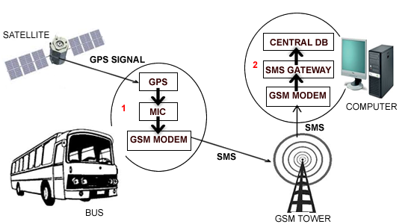



Generates Road Traffic Offender Ticket

Captured Road Traffic Offences

Generates Road Traffic Offender Ticket

Captured Road Traffic Offences

Figure 4.1**: Implementation Architecture**

In the proposed implementation architecture, the presentation layer designed using HTML as the User Interface, the application layer designed using PHP that runs on the server and the data layer designed using mySQL database server (XAMPP control panel) is installed in the computer systems. The computer system captures road traffic offence, saves the information in the road traffic offence information database, where each computer system can easily access the database information.

**4.4 Software Testing**

The unit testing approach was adopted in testing the codes written. The procedure adopted for the unit test is;

1. The module interface is tested to ensure that information properly flows into and out of the program unit under test.

2. The local data structure is examined to ensure that data stored temporarily maintained its integrity during all steps in an algorithm’s execution.

3. All the statements are executed at least once and error handling paths are tested

**4.5 Documentation**

Documentation is very important in the development of any software application. This is because documentation makes the software application easier to all users, and if an application is not well documented it becomes difficult to use.

**Hardware Requirement:**

The software application designed needed the following hardware for effective operation of the newly designed system:

* Pentium IV system.
* The Random Access Memory (RAM) should be at least 128KB
* Enhanced Keyboard.
* At least 20GB hard Disk.
* E.G.A/V.G.A, a coloured Monitor.
* An uninterruptible Power Supply (UPS) Units
* Laserjet or Deskjet Printer.
* Voltage Stabilizer: This facilitates the regulation of voltage needed

by the computer system in order to avoid electrical damage of the system.

**Software Requirements**

The software requirements for this system include:

* A window XP/ Vista/Window 7 Operating System.
* Structured Query Language (mySQL)
* PHP console
* HTML
* Apache server

In making use of the software application, the user has to first boot the system, after installing the rapid PHP IDE and XAMPP applications in his/her computer system. To install the software application, A Road Traffic Offence System, insert the CD into a CD-ROM drive of the computer system that has met with the above software and hardware requirements then follow the steps below:

* Go to run;
* Click browse button in the run dialog box
* Navigate to your CD-ROM driver and select it to open its content.
* Double click on the set up item to set the software up in the system
* Follow the on screen instruction to complete the setup

**4.5.1 User Manual**

The end user can make use of the software application by following the steps below:

* Double clicking on the rapid PHP IDE icon on the computer desktop to launch the IDE.
* Next click on the View menu and select File Explorer submenu, click on Traffic folder, then double click on Index.
* Next go to PHP menu, select Debug sub menu and then click on Run that appears to run the application.

After interacting with the application and the user intends to terminate the application:

* Click on the Close button to terminate the application.

To terminate the IDE:

* Go to File menu, then select Exit sub menu.

The software application is developed in such a way that both computer professionals and non computer professionals, with the knowledge of computer can use it. Meaning that the software application is user friendly and interactive.

**CHAPTER FIVE**

**SUMMARY AND CONCLUSION**

**5.1 Summary**

The existing approach of decentralised road traffic offence information is not efficient as having single integrated road traffic offence information enhances fast, timely and secured accessibility and sharing of road traffic offence information for the agency’s decision making. Manual means of identifying offender with only information about an offender is not enough, Identifying road traffic offenders with their pictorial images will aid the agency in authentic documentation and avoid prosecuting wrong persons. In the same line, as pragmatic beings who believe what they see, showing offender a display diagram sketch of his crime will convince him .This also will provide forensic evidence that will facilitate prosecutions. The proposed model is anticipated to offer an improved solution in road traffic offence information management in real time despite the geographical locations. If the proposed model will be implemented it is expected to improve transparency and accountability and therefore strengthening road safety.

The system is designed using Object Oriented Analysis and Design and Unified Modelling Language was used to bring the view to real life situation. Top down approach was adopted as the implementation approach for this project research. This involves breaking complex system into subsystems and then into modules for easy study and understanding. The system architecture is basically divided into three basic parts. The first is the front end that shows the user interface designed with PHP, HTML and JavaScript, the back end which hold the database server and different tables, at the middle is the internet Information Service or application server using the Apache server; which provides the connectivity between the front end and the back end. The user interfaces are interactive and provisions are made for security of data stored. The use of the system is relatively simple and the I.T knowledge requirement for its usage is relatively minimal.

The system is reusable, meaning that it can be further expanded or more other features can still be added into the system to strengthen and better the system.

**Review of Achievements**

Decentralised road traffic offence information is not efficient as having single integrated road traffic offence information enhances fast, timely and secured accessibility and sharing of road traffic offence information for FRSC’s management and decision making. Manual means of identifying offender with only information about an offender is poor. Identifying road traffic offenders with their pictorial images will aid the agency in authentic documentation and avoid prosecuting wrong persons. In the same line, as pragmatic beings who believe what they see, showing offender a display diagram sketch of his crime will convince him .This also will provide forensic evidence that will facilitate prosecutions. The proposed model is anticipated to offer an improved solution in road traffic offence information management in real time despite the geographical locations. If the proposed model will be implemented it is expected to improve transparency and accountability and therefore strengthening road safety. Figure 5.1 depicts prospective users’ assessment (in %) of the proposed model



Figure 5.1: Prospective users’ assessment

Prospective users’ opinions in rating the practicability of the proposed system was reviewed and analyzed. In summary, the results showed that, the proposed model’s advantages would overweigh that of the existing system. Few parameters were used for assessing proposed system to see whether it will improve; Reliability, Accountability, Transparency, Road Safety and how feasible would the solution be.

**Areas of Application of Work**

FRSC, the leading and coordinating charged with the responsibility of playing role as the key driver of all road safety efforts in Nigeria. While this is essential for achieving the goal of the road traffic offence safe system approach, unfortunately it has become unattainable due to its current involvement in managing road traffic offence at operational level, a position it shares with several other agencies also duly empowered to perform similar functions.

While a shared road safety responsibility provides the benefits of coverage where cross-functional gaps exist, it portends the dangers of role- submergence and conflict which may arise out of competing interests. It is disturbing that such conflicts currently characterize road traffic offence information management activities in Nigeria. For instance, the Nigeria Police Force is constitutionally empowered to act as the primary enforcement agency of all traffic laws and regulations of the Federal, State and Local governments in the country. This function it performs through its Motor Traffic Division. Thus like the FRSC, the Police carries out road patrols, vehicle checks, and prosecute traffic offenders. The Vehicle Inspection Officers (VIO) is constitutionally mandated to issue and renew Licences for all private and commercial vehicle drivers, and issue such permits as Hackney Carriages, Stage Carriages, and Goods Carriages. They also regulate fares and register new vehicles and keep a register of such in all states of the Federation. It is with this body that FRSC faces the greatest conflict especially in carrying out some of its important road safety activities. There are other Federal Ministries (e.g. Transport, Works), State Ministries e.g. Works and Transport; Transport Regulatory Authorities; Local Government Councils; and Trade Unions e.g. National Union of Road Transport Workers (NURTW) who are empowered to play either persuasive, preventive or punitive safety roles in the country. Conventionally, the FRSC is expected to coordinate the activities of these bodies in order to improve road safety, but their linkages are either nonexistent or at best weak and in a few cases they even operate at cross-purposes.

Road traffic offence information management system deals with road traffic offence information and how better to manage the information for the purpose of ensuring road traffic safety. The system can be better applied in the road traffic offence documentation section of FRSC units, sectors and zonal commands.

**Contributions to Knowledge**

In the study, the author was able to establish that major cause of road accidents being experienced in Nigeria is due to road traffic offence information management failure and inadequate information and communication technology facilities in road safety activities. Improved road traffic offence information management through single integrated road traffic offence information database and credible offenders’ identification measure was proposed and developed. The system model can also display in form of diagram sketch/picture an offenders’ crime, to facilitate prosecution.

**Suggestion for Further Work**

* The author suggests that a research to develop system that relies on thousands of sensors embedded in asphalt, some attached to street signs and hidden in traffic lights and others posted at major streets and key intersections to capture data on traffic flows and density. The system will be capable of capturing snapshots of road traffic offences and then deliver it, wirelessly to computer servers. Computers then combine this information with FRSC field staff dispatches on road traffic offence, accidents or emergencies and deliver it to users who can access it on their PDA or Mobile phones and the internet. The system can also predict what road traffic condition will be like in several hour
* A research to develop a system that allows documentations of road traffic offence be done via mobile applications. The mobile application system will allow the use of mobile devices to capture and document offence information as well as allowing accessibility through mobile devices.GPS, WiFi, GSM, Google maps will be used as development technologies to create application usable by people responsible for the administration of applications, but also usable by final users. Also to be known as road traffic offence management on the palm, the application will be able to display road traffic offence information that is currently happening on the major roads. It will enable users to find the current location using GPS and displays location on the screen. The location is to be displayed on the map of Google maps package. After presentation of the user’s location on the map, there will be on the map drown different markers, depending on what kind of event is in question. Touching the screen, where the event is, and users can get road traffic information in details, whether there is road traffic accident or road traffic offence. This application will help the user to be promptly informed about working zones, road traffic accidents, road traffic offence, which reduces the risk of downtime, and significantly shortens the time required for the identification and solving of road traffic incidents.

Incorporating the above functionalities with Road Traffic Offence Information Management System will reduce to the barest minimum the rate of road traffic offence in Nigeria.

**5.2 Recommendations**

Federal Road Safety Corps as the lead and coordinating agency for road safety management in Nigeria is the key driver of all road safety efforts in Nigeria. This has become unattainable due to its current involvement in managing road safety at operational level, a position it shares with several other agencies like the Nigeria Police Force, the Vehicle Inspection Officers (VIO), Works and Transport; Transport Regulatory Authorities, National Union of Road Transport Workers (NURTW) also duly empowered to perform similar functions this portends the dangers of role- submergence and conflict which may arise out of competing interests. FRSC should coordinate the activities of these bodies in order to improve road traffic offence information management.

* Information and Communication Technology seminar training and retraining should be giving to staff of the FRSC so as to be abreast with international road safety standards.
* Public enlightenment on dangers of road traffic offence and stipulated penalties should be common jingle in the media. Telecommunication companies should also join the queue of enlightening their network users.
* Researches on better way to improve road traffic offence information management should be encouraged and supported by all.

**5.3 Conclusion**

FRSC, plays the role as the leading and coordinating agency for road safety management in Nigeria, Unfortunately this has become unattainable due to its current involvement in managing road safety at operational level; a position it shares with several other agencies also duly empowered to perform similar functions. Though shared road safety responsibility provides the benefits of coverage where cross-functional gaps exist, it also portends danger in role submergence and conflict which may arise out of competing interests. It is disturbing to note that such conflict currently characterize road traffic offence information management in Nigeria. The main challenge of implementing road traffic offence information management in any developing country is to fully embrace improved information and communication technology in road traffic information management, especially as regards to offence management. This will go a long way to reduce incessant accidents in Nigeria.

The research shows that significant reduction of road crashes can be achieved by the prudent management of road traffic offence information through application of adequate ICT infrastructure, increasing access to road safety information. Not just amassing huge data for road safety management, every electronic data, including sensitive road traffic offence information is useless if it is not accessible and proper identification of road traffic offenders made during documentation to ensure reliability and credibility of the process.

The way in which all officials involved would use the technology and mechanisms provided, will determine the system’s effectiveness in enforcing road traffic offence management control. The integrity and dedication of these officials are among important factors in our struggle against road traffic offences. It is trusted that the efforts and investment in Road Traffic Offence Information Management System will result in the much-needed positive benefits toward road traffic offences and accidents reduction in Nigeria.

**APPENDIX D**

**Screen Shots of Demos**

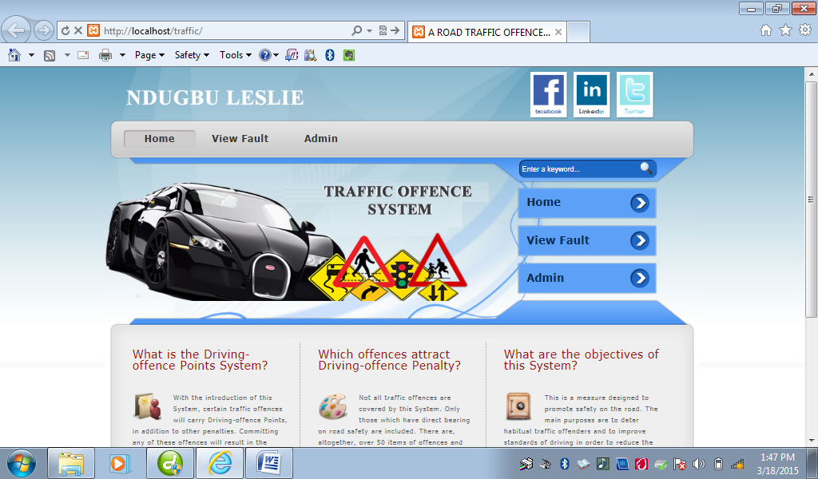

**Figure 4.2: Home Page Screen Shot**

Road Traffic Offence Information management System home page allow FRSC staff get to the Admin-Login when their click on Admin menu.

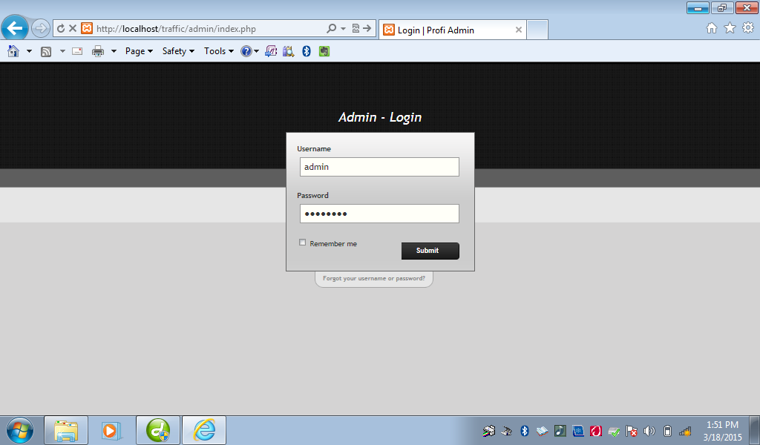

**Figure 4.3: Admin-Login Page Screen Shot.**

Here, FRSC staff enter the appropriate username and password to formally log-in and access different menus and various links in the page, such as Register Offender, View Offender, Generate Ticket, Settings, etc.

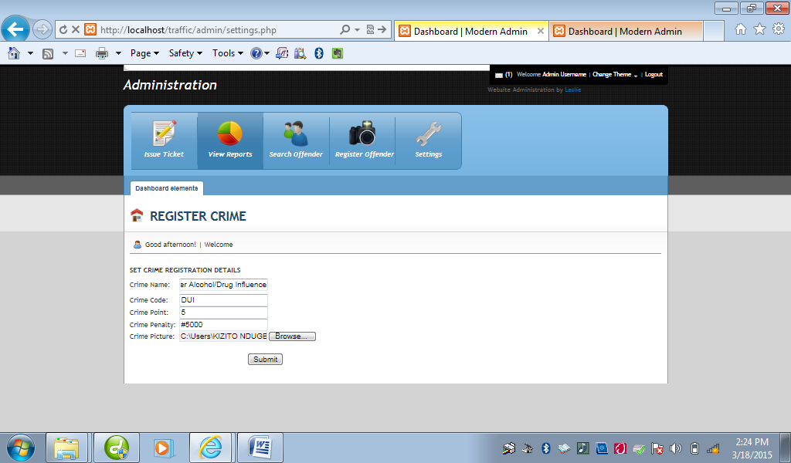

**Figure 4.4: Register Crime or Crime Settings Page Screen Shot**

Here, Staff register all possible crimes according to crime name, crime point, crime code, crime penalty and crime picture and then save them, so that anytime he wants to register an offender, he will just select among the already registered crimes, automatically the crime penalty will follow it.

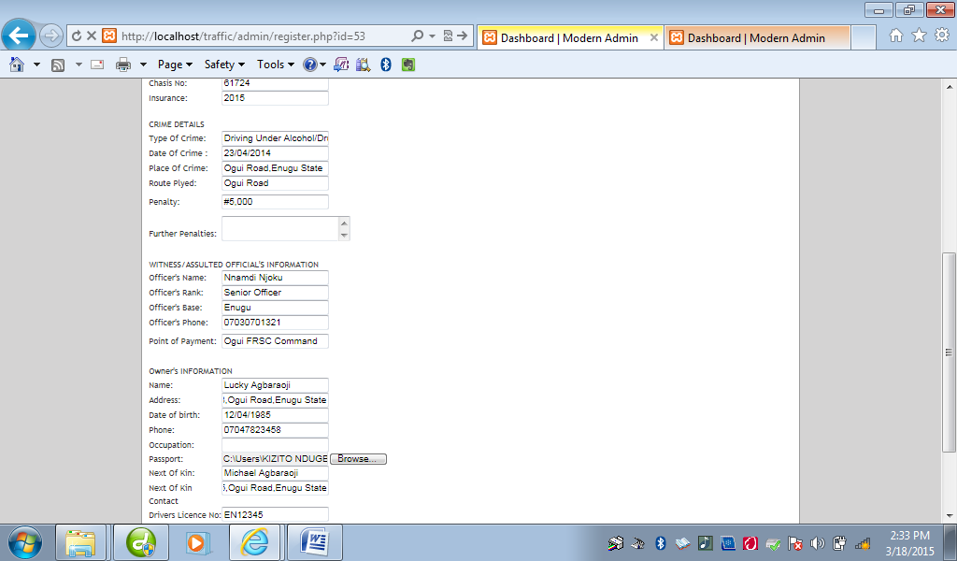

**Figure 4.5: Register Offender Page Screen Shot**

Here, Staff captures the offender’s information, his passport and finally saves them for future references.

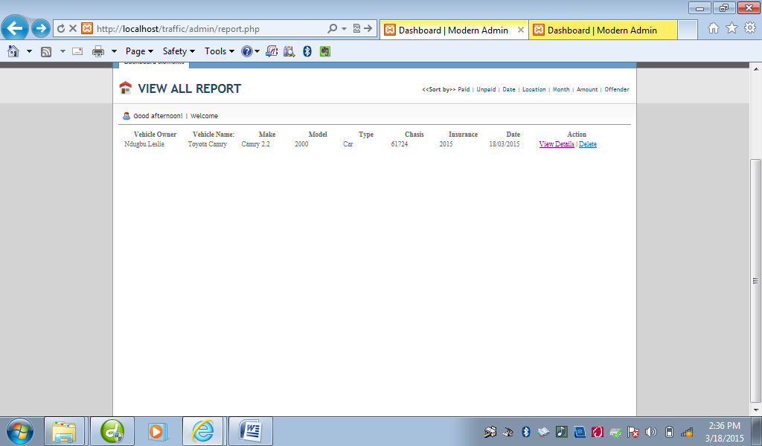

**Figure 4.6: View All Report Page Screen shot**

Here, Staff can view all Offenders’ report including their names, vehicle name, Make etc. Here, the staff can now view a particular offender’s report by clicking on view detail.

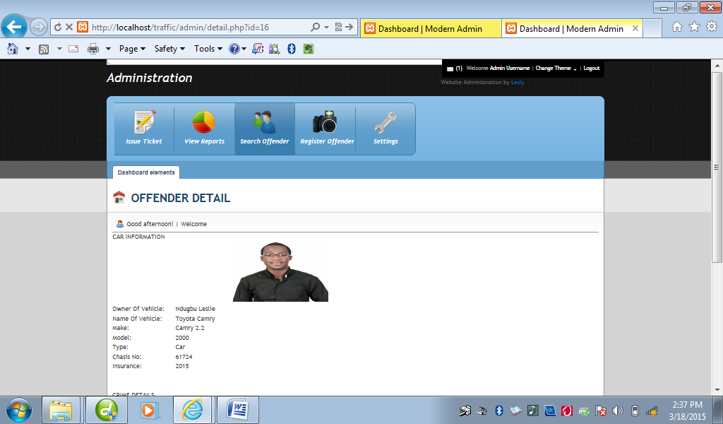

**Figure 4.7: Offender Detail Page screen shot**

Here, Staff can view a particular offender’s information in a more detail manner, showing the Offender’s passport, crime committed, Penalty, date of crime, route plying when offence was committed, etc.

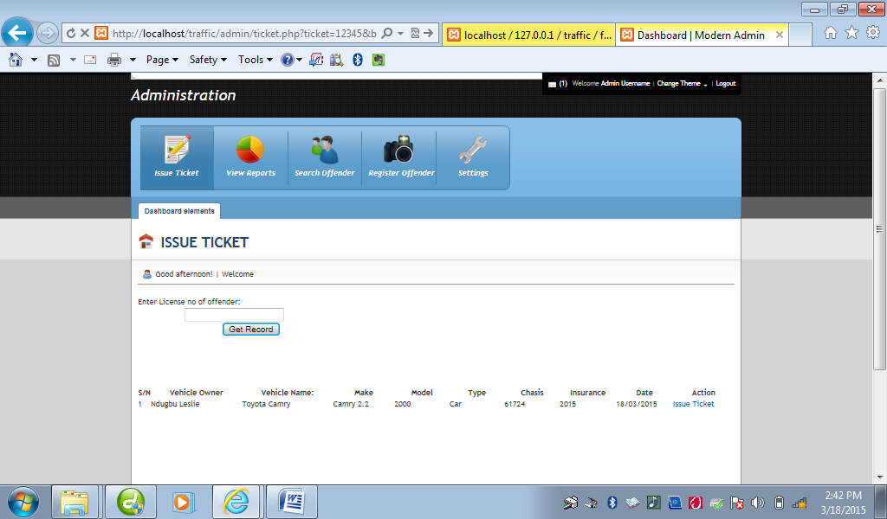

**Figure 4.8: Issue Ticket Page Screen Shot**

Here, Staff is asked to enter offender’s driving licence as used during registration to be able to generate an offender ticket for the offender. When staff enters the licence number, then click on get record, the offenders report appears, then double click on issue ticket, the offender’s ticket will be automatically generated.

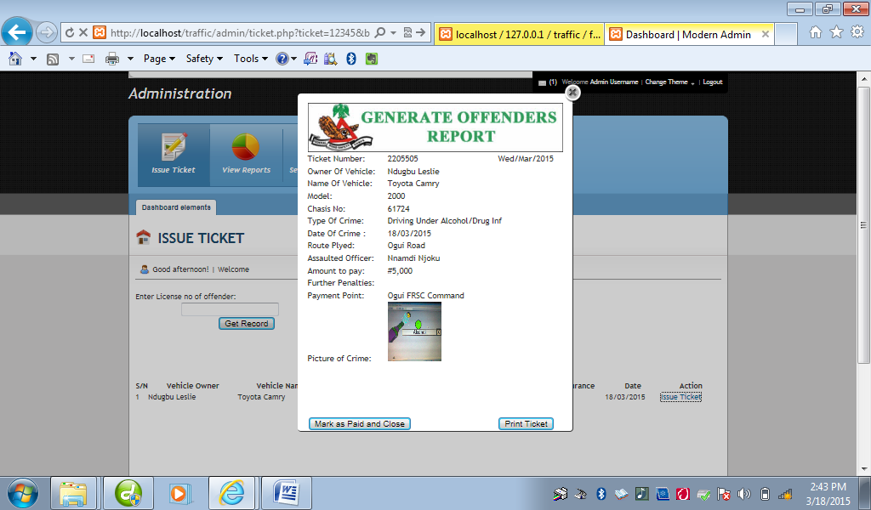

**Figure 4.9: Offender Ticket Page Screen Shot**

Here, the staff can now print and issue the offender his ticket for him to see the crime he committed, the penalty and crime picture, where he will go make his payment, etc.

**APPENDIX E**

**Source Codes**

<?php

include('func.php');

define("SERVER", "localhost");

define("USER", "root");

define ("PASS", "");

define("DBASE1", "traffic");

if(isset($_GET['fm'])){

$connection = mysql_connect(SERVER,USER,PASS);

$dbselection = mysql_select_db(DBASE1);

$cname = trim($_POST['cname']);

$ccode = trim($_POST['ccode']);

$cpoint = trim($_POST['cpoint']);

$cpena = trim($_POST['cpena']);

$target = "../crimepix/";

$target = $target . basename($_FILES['uploadedfile']['name']);

move_uploaded_file($_FILES['uploadedfile']['tmp_name'],$target);

$sql = "INSERT INTO ctype(name,code,point,penalty,crimepix) VALUES('$cname','$ccode','$cpoint','$cpena','$target')";

$rs = mysql_query($sql);

confirm($rs);

visit("../admin/settings.php?sx=1");

}

else{

$connection = mysql_connect(SERVER,USER,PASS);

$dbselection = mysql_select_db(DBASE1);

$vowner =trim($_POST['vowner']);

$vname = trim($_POST['vname']);

$vmake =trim($_POST['vmake']);

$vmodel = trim($_POST['vmodel']);

$vtype =trim($_POST['vtype']);

$vchasis = trim($_POST['vchasis']);

$vinsurance =trim($_POST['vinsurance']);

$vstateofp = trim($_POST['vstateofp']);

$ctype =trim($_POST['ctype']);

$cdate = trim($_POST['cdate']);

$cplace =trim($_POST['cplace']);

$croute = trim($_POST['croute']);

$oname = trim($_POST['oname']);

$oaddress = trim($_POST['oaddress']);

$odate = trim($_POST['odate']);

$penalty = trim($_POST['penalty']);

$oocc = trim($_POST['oocc']);

$onok = trim($_POST['onok']);

$onokphone = trim($_POST['onokphone']);

$olicense = trim($_POST['olicense']);

$ophone = trim($_POST['ophone']);

$cdate = trim(date("d/m/Y"));

$status = "0";

$mnth = date("m");

$target = "../upload/";

$tno = rand(0,9999999);

$pplus = trim($_POST['pplus']);

$ooname = trim($_POST['ooname']);

$orank = trim($_POST['orank']);

$obase = trim($_POST['obase']);

$pix = trim($_POST['pixx']);

$oophone = trim($_POST['oophone']);

$point = trim($_POST['point']);

$target = $target . basename($_FILES['uploadedfile']['name']);

$protopic = $target;

move_uploaded_file($_FILES['uploadedfile']['tmp_name'],$target);

$sql = "INSERT INTO faults(vowner,vname,vmake,vmodel,vtype,vchasis,vinsurance,vstateofp,ctype,cdate,cplace

,croute,oname,oaddress,odate,penalty,oocc,opassport,onok,onokphone,olicense,ophone,tno,pplus,ooname,orank,obase,oophone,point,crimepix,mnth,status)

VALUES('$vowner','$vname','$vmake','$vmodel','$vtype','$vchasis','$vinsurance','$vstateofp','$ctype','$cdate','$cplace','$croute','$oname','$oaddress','$odate','$penalty','$oocc','$protopic','$onok','$onokphone','$olicense','$ophone','$tno','$pplus','$ooname','$orank','$obase','$oophone','$point','$pix','$mnth','$status')";

$rs = mysql_query($sql);

confirm($rs);

visit("../admin/register.php?sx=1");

}

?>

<?php

define("SERVER", "localhost");

define("USER", "root");

define ("PASS", "");

define("DBASE1", "traffic");

function visit($link){

header("Location: {$link}");

exit;

}

if (isset($_GET['mm'])){

if(fm==1){ticket();}

else{}

}

function confirm($result){

if (!$result){

die("Could not connect " . mysql_error());

}}

function recent_questions(){

define("SERVER", "localhost");

define("USER", "starnetw_admin");

define ("PASS", "p@55word");

define("DBASE1", "archive");

$connection = mysql_connect(SERVER,USER,PASS);

$dbselection = mysql_select_db(DBASE1);

global $connection;

$query = "SELECT * FROM docs";

$query .= " ORDER BY `id` DESC";

$messages = mysql_query($query, $connection);

confirm($messages);

$i = 0;

while ($sub = mysql_fetch_array($messages))

{

echo $sub["fname"];

}

}

function display(){

$connection = mysql_connect(SERVER,USER,PASS);

$dbselection = mysql_select_db(DBASE1);

echo "<table>

<tr style=\"text-align:left\">

<th width=\"120\" class=\"first\"><strong>Vehicle Owner</strong></th>

<th width=\"100\">Vehicle Name:</th>

<th width=\"100\">Make</th>

<th width=\"90\">Model</th>

<th width=\"90\">Type</th>

<th width=\"90\">Chasis</th>

<th width=\"90\">Insurance</th>

<th width=\"90\">Date</th>

<th width=\"90\">Action</th>

</tr>";

global $connection;

if(isset($_GET['field'])){

$query = "SELECT * FROM faults";

$query .= " ORDER BY `".$_GET['field']."` DESC";

}elseif(isset($_GET['pd'])){

$query = "SELECT * FROM faults WHERE status = '0'";

$query .= " ORDER BY `id` DESC";

}elseif(isset($_GET['npd'])){

$query = "SELECT * FROM faults WHERE status = '1'";

$query .= " ORDER BY `id` DESC";

}

else{

$query = "SELECT * FROM faults";

$query .= " ORDER BY `id` DESC";

}

$messages = mysql_query($query);

confirm($messages);

$i = 0;

while ($sub = mysql_fetch_array($messages))

{

$doc = "<tr class=\"row-a\">";

$doc .= "<td class=\"first\">".$sub['vowner'] ."</td>";

$doc .= "<td class=\"first\">".$sub['vname'] ."</td>";

$doc .= "<td class=\"first\">".$sub['vmake'] ."</td>";

$doc .= "<td class=\"first\">".$sub['vmodel'] ."</td>";

$doc .= "<td class=\"first\">".$sub['vtype'] ."</td>";

$doc .= "<td class=\"first\">".$sub['vchasis'] ."</td>";

$doc .= "<td class=\"first\">".$sub['vinsurance'] ."</td>";

$doc .= "<td class=\"first\">".$sub['cdate'] ."</td>";

$doc .= "<td style=\"width:150px;\"><a href=\"detail.php?id=". $sub['id'] ."\" target='_parent\' >View Details</a> | <a href=\"delete.php?id=". $sub['id'] ."\">Delete</a></td>";

$doc .= "</tr>";

echo $doc;

}

echo "</table>";

}

function fetch($varr){

$connection = mysql_connect("localhost","root","");

$dbselection = mysql_select_db("traffic");

global $connection;

$query = "SELECT * ";

$query .= "FROM faults";

$query .= " WHERE id = ";

$query .= $_GET['id'];

//$query .= " LIMIT 1";

$result = mysql_query($query);

confirm($result);

$uname = mysql_fetch_array($result);

echo $uname[$varr];

}

function install(){

$con=mysqli_connect("localhost","root","","car");

// Check connection

if (mysqli_connect_errno())

{

visit("lib/install.php");

}

}

function ticket(){

if (isset($_GET['ticket'])){

$connection = mysql_connect(SERVER,USER,PASS);

$dbselection = mysql_select_db(DBASE1);

echo "<table>

<tr>

<th width=\"20\" class=\"first\"><strong>S/N</strong></th>

<th width=\"150\" class=\"first\"><strong>Vehicle Owner</strong></th>

<th width=\"150\">Vehicle Name:</th>

<th width=\"100\">Make</th>

<th width=\"90\">Model</th>

<th width=\"90\">Type</th>

<th width=\"90\">Chasis</th>

<th width=\"90\">Insurance</th>

<th width=\"90\">Date</th>

<th width=\"100\">Action</th>

</tr>";

global $connection;

$query = "SELECT * FROM faults WHERE olicense = ";

$query .= $_GET['ticket'];

$query .= " ORDER BY `id` DESC";

$messages = mysql_query($query) or die ("No record found");

$i = 0;

while ($sub = mysql_fetch_array($messages))

{

$doc = "<tr class=\"row-a\">";

$doc .= "<td class=\"first\">".$i += 1 ."</td>";

$doc .= "<td class=\"first\">".$sub['vowner'] ."</td>";

$doc .= "<td class=\"first\">".$sub['vname'] ."</td>";

$doc .= "<td class=\"first\">".$sub['vmake'] ."</td>";

$doc .= "<td class=\"first\">".$sub['vmodel'] ."</td>";

$doc .= "<td class=\"first\">".$sub['vtype'] ."</td>";

$doc .= "<td class=\"first\">".$sub['vchasis'] ."</td>";

$doc .= "<td class=\"first\">".$sub['vinsurance'] ."</td>";

$doc .= "<td class=\"first\">".$sub['cdate'] ."</td>";

$doc .= "<td style=\"width:100px;\"><span onclick=\"TINY.box.show({url:'print.php?id=". $sub['id'] ."',post:'id=16',width:400,height:500,opacity:20,topsplit:3})\"><a href=\"#\">Issue Ticket</a>";

$doc .= "</span></tr>";

echo $doc;

}

echo "</table>";

}

}

function view($varr){

if (isset($_GET['license'])){

$connection = mysql_connect("localhost","root","");

$dbselection = mysql_select_db("traffic");

global $connection;

$query = "SELECT * ";

$query .= "FROM faults";

$query .= " WHERE olicense = ";

$query .= $_GET['license'];

//$query .= " LIMIT 1";

$result = mysql_query($query) or die ("Record not found");

$uname = mysql_fetch_array($result);

echo $uname[$varr];

}

}

function populate(){

$connection = mysql_connect(SERVER,USER,PASS);

$dbselection = mysql_select_db(DBASE1);

global $connection;

$query = "SELECT * FROM ctype";

$messages = mysql_query($query) or die ("No record found");

while ($sub = mysql_fetch_array($messages))

{

$doc = "<option value=\"register.php?id=";

$doc .= $sub['id'];

$doc .="\">";

$doc .=$sub['name'];

$doc .="</option>";

echo $doc;

}

}

function populated($var){

if (isset($_GET['id'])){

$connection = mysql_connect(SERVER,USER,PASS);

$dbselection = mysql_select_db(DBASE1);

global $connection;

$query = "SELECT * FROM ctype where id = ";

$query .= $_GET['id'];

$messages = mysql_query($query) or die ("No record found");

$sub = mysql_fetch_array($messages);

$doc = $sub[$var];

echo $doc;

}}

?>

<?php

include("func.php");

$con=mysqli_connect("localhost","root","");

// Check connection

if (mysqli_connect_errno())

{

echo "Failed to connect to MySQL: " . mysqli_connect_error();

}

// Create database

$sql="CREATE DATABASE car";

if (mysqli_query($con,$sql))

{

tables();

}

else

{

echo "Error creating database: " . mysqli_error();

}

function tables(){

$con=mysqli_connect("localhost","root","","car");

// Check connection

if (mysqli_connect_errno())

{

echo "Failed to connect to MySQL: " . mysqli_connect_error();

}

// Create table

$sql="CREATE TABLE cars

(

id INT NOT NULL AUTO_INCREMENT,

PRIMARY KEY(id),

cmake CHAR(30),

cmodel CHAR(30),

ccolor CHAR(50),

cengineno CHAR(50),

cchasisno CHAR(30),

cdateofpurchase CHAR(30),

ccountryofpurchase CHAR(30),

cstateofpurchase CHAR(30),

coname CHAR(30),

coaddress CHAR(30),

coemail CHAR(30),

cophone CHAR(30),

cooccupation CHAR(30),

copassport CHAR(100),

conok CHAR(30),

codateofreg CHAR(30),

colicenceno CHAR(30)

)";

// Execute query

if (mysqli_query($con,$sql))

{

visit("../index.php");

}

else

{

echo "Error creating table: " . mysqli_error();

}

}

?>

<?php include('lib/func.php');?>

<!DOCTYPE html PUBLIC "-//W3C//DTD XHTML 1.0 Transitional//EN" "http://www.w3.org/TR/xhtml1/DTD/xhtml1-transitional.dtd">

<html xmlns="http://www.w3.org/1999/xhtml">

<head>

<meta http-equiv="Content-Type" content="text/html; charset=utf-8" />

<title>A ROAD TRAFFIC OFFENCE SYSTEM</title>

<meta name="keywords" content="Light Space Template, CSS Templates, Website Templates, Free Download" />

<meta name="description" content="Light Space Template - one of the Free CSS Templates by templatemo.com" />

<link href="templatemo_style.css" rel="stylesheet" type="text/css" />

<script language="javascript" type="text/javascript">

function clearText(field)

{

if (field.defaultValue == field.value) field.value = '';

else if (field.value == '') field.value = field.defaultValue;

}

</script>

</head>

<body>

<div id="templatemo_wrapper">

<div id="templatemo_site_title_bar">

<div id="site_title">

<h1><a href="http://www.blazingprojects.com" target="_parent">

<img src="images/logo.png" alt="Light Space" />

<!-- <span>free css templates</span> -->

</a></h1>

</div>

<ul class="social_network">

<li><a href="http://www.facebook.com/templatemo" target="_parent"><img src="images/facebook_icon.png" alt="facebook" /></a></li>

<li><a href="http://www.facebook.com/templatemo" target="_parent"><img src="images/linkin_icon.png" alt="linkin" /></a></li>

<li><a href="http://www.facebook.com/templatemo" target="_parent"><img src="images/twitter_icon.png" alt="twitter" /></a></li>

</ul>

</div> <!-- end of templatemo_site_title_bar -->

<div id="templatemo_menu">

<ul>

<li><a href="index.php" class="current">Home</a></li>

<li><a href="view.php" target="_parent">View Cars</a></li>

<li><a href="reg.php" target="_parent">Register Car</a></li>

<li><a href="#">.</a></li>

<li><a href="#">.</a></li>

</ul>

</div> <!-- end of templatemo_menu -->

<div id="templatemo_search">

<div id="search_box">

<form action="#" method="get">

<input type="text" value="Enter a keyword..." name="q" size="10" id="searchfield" title="searchfield" onfocus="clearText(this)" onblur="clearText(this)" />

<input type="submit" name="Search" value="" alt="Search" id="searchbutton" title="Search" />

</form>

</div>

</div> <!-- end of search -->

<div id="templatemo_banner">

<div id="banner_right">

<div class="banner_button"> <a href="reg.php">Register Car</a> </div>

<div class="banner_button"> <a href="view.php">View Cars</a> </div>

</div>

</div> <!-- end of templatemo_banner -->

<div id="templatemo_content_top"></div>

<div id="templatemo_content">

<div class="section_w940">

<h3>This project work has been developed for use in m.sc project defence by Ndugbu Leslie N. and all rights reserved</h3>

<div class="cleaner"></div>

</div>

</div>

<div id="templatemo_content_bottom"></div>

<div id="templatemo_footer">

<div class="cleaner_h40"></div>

<center>

Copyright © 2014 Computer Science Msc Project<a href="#"></a> |

Designed by <a href="http://www.blazinprojects.com" target="_parent">Ndugbu Leslie</a><a href="http://jigsaw.w3.org/css-validator/check/referer"></a>

</center>

</div> <!-- end of footer -->

</div> <!-- end of wrapper -->

</body>

</html>

<!DOCTYPE html PUBLIC "-//W3C//DTD XHTML 1.0 Transitional//EN" "http://www.w3.org/TR/xhtml1/DTD/xhtml1-transitional.dtd">

<html xmlns="http://www.w3.org/1999/xhtml">

<head>

<meta http-equiv="Content-Type" content="text/html; charset=utf-8" />

<title>Untitled Document</title>

<style type="text/css">

body{margin:0px; padding:0px;}

.bg{height:160px; width:300px; background-color:#CCCCCC;}

</style>

</head>

<body>

<div class="bg">

<form id="form1" name="form1" method="post" action="">

<table width="294" border="0">

<tr>

<td height="35" colspan="3" style="text-align:center; font-size:14px; font-weight:bold; border:thin 1px; border:#FFF;">Admin Login</td>

</tr>

<tr>

<td height="21" colspan="3">&nbsp;</td>

</tr>

<tr>

<td width="73" height="25">Username:</td>

<td colspan="2"><label for="textfield"></label>

<input type="text" name="textfield" id="textfield" /></td>

</tr>

<tr>

<td height="23">Password:</td>

<td colspan="2"><label for="textfield2"></label>

<input type="text" name="textfield2" id="textfield2" /></td>

</tr>

<tr>

<td height="23">&nbsp;</td>

<td width="78">&nbsp;</td>

<td width="129"><input type="submit" name="button" id="button" value=".:: Login ::." /></td>

</tr>

</table>

</form>

</div>

</body>

</html>

<?php include('lib/func.php');?>

<!DOCTYPE html PUBLIC "-//W3C//DTD XHTML 1.0 Transitional//EN" "http://www.w3.org/TR/xhtml1/DTD/xhtml1-transitional.dtd">

<html xmlns="http://www.w3.org/1999/xhtml">

<head>

<meta http-equiv="Content-Type" content="text/html; charset=utf-8" />

<title>ON-LINE VEHICLE REGISTRATION</title>

<meta name="keywords" content="Light Space Template, CSS Templates, Website Templates, Free Download" />

<meta name="description" content="Light Space Template - one of the Free CSS Templates by templatemo.com" />

<link href="templatemo_style.css" rel="stylesheet" type="text/css" />

<script language="javascript" type="text/javascript">

function clearText(field)

{

if (field.defaultValue == field.value) field.value = '';

else if (field.value == '') field.value = field.defaultValue;

}

</script>

</head>

<body>

<div id="templatemo_wrapper">

<div id="templatemo_site_title_bar">

<div id="site_title">

<h1><a href="http://www.blazingprojects.com" target="_parent">

<img src="images/logo.png" alt="Light Space" />

<!-- <span>free css templates</span> -->

</a></h1>

</div>

<ul class="social_network">

<li><a href="http://www.facebook.com/templatemo" target="_parent"><img src="images/facebook_icon.png" alt="facebook" /></a></li>

<li><a href="http://www.facebook.com/templatemo" target="_parent"><img src="images/linkin_icon.png" alt="linkin" /></a></li>

<li><a href="http://www.facebook.com/templatemo" target="_parent"><img src="images/twitter_icon.png" alt="twitter" /></a></li>

</ul>

</div> <!-- end of templatemo_site_title_bar -->

<div id="templatemo_menu">

<ul>

<li><a href="index.php" class="current">Home</a></li>

<li><a href="view.php" target="_parent">View Cars</a></li>

<li><a href="reg.php" target="_parent">Register Car</a></li>

<li><a href="about.php" target="_parent">About</a></li>

<li><a href="#">.</a></li>

<li><a href="#">.</a></li>

</ul>

</div> <!-- end of templatemo_menu -->

<div id="templatemo_search">

<div id="search_box">

<form action="#" method="get">

<input type="text" value="Enter a keyword..." name="q" size="10" id="searchfield" title="searchfield" onfocus="clearText(this)" onblur="clearText(this)" />

<input type="submit" name="Search" value="" alt="Search" id="searchbutton" title="Search" />

</form>

</div>

</div> <!-- end of search -->

<div id="templatemo_banner">

<div id="banner_right">

<div class="banner_button"> <a href="reg.php">Register Car</a> </div>

<div class="banner_button"> <a href="view.php">View Cars</a> </div>

<div class="banner_button"> <a href="about.php">About</a> </div>

</div>

</div> <!-- end of templatemo_banner -->

<div id="templatemo_content_top"></div>

<div id="templatemo_content">

<div class="section_w940">

<h3>Congratulations, The new car have been registered successfully&nbsp;</h3>

<div class="cleaner"></div>

</div>

</div>

<div id="templatemo_content_bottom"></div>

<div id="templatemo_footer">

<div class="cleaner_h40"></div>

<center>

Copyright © 2014 Computer Science Msc Project<a href="#"></a> |

Designed by <a href="http://www.blazinprojects.com" target="_parent">Ndugbu Leslie</a><a href="http://jigsaw.w3.org/css-validator/check/referer"></a>

</center>

</div> <!-- end of footer -->

</div> <!-- end of wrapper -->

</body>

</html>

<?php include('lib/func.php');

$id = $_GET['id'];

$get = fetch('cars','id',$id);?>

<!DOCTYPE html PUBLIC "-//W3C//DTD XHTML 1.0 Transitional//EN" "http://www.w3.org/TR/xhtml1/DTD/xhtml1-transitional.dtd">

<html xmlns="http://www.w3.org/1999/xhtml">

<head>

<meta http-equiv="Content-Type" content="text/html; charset=utf-8" />

<title>ON-LINE VEHICLE REGISTRATION</title>

<meta name="keywords" content="Light Space Template, CSS Templates, Website Templates, Free Download" />

<meta name="description" content="Light Space Template - one of the Free CSS Templates by templatemo.com" />

<link href="templatemo_style.css" rel="stylesheet" type="text/css" />

<script language="javascript" type="text/javascript">

function clearText(field)

{

if (field.defaultValue == field.value) field.value = '';

else if (field.value == '') field.value = field.defaultValue;

}

</script>

<style type="text/css">

.first{text-align:center;}

</style>

</head>

<body>

<div id="templatemo_wrapper">

<div id="templatemo_site_title_bar">

<div id="site_title">

<h1><a href="http://www.blazingprojects.com" target="_parent">

<img src="images/logo.png" alt="Light Space" />

<!-- <span>free css templates</span> -->

</a></h1>

</div>

<ul class="social_network">

<li><a href="http://www.facebook.com/templatemo" target="_parent"><img src="images/facebook_icon.png" alt="facebook" /></a></li>

<li><a href="http://www.facebook.com/templatemo" target="_parent"><img src="images/linkin_icon.png" alt="linkin" /></a></li>

<li><a href="http://www.facebook.com/templatemo" target="_parent"><img src="images/twitter_icon.png" alt="twitter" /></a></li>

</ul>

</div> <!-- end of templatemo_site_title_bar -->

<div id="templatemo_menu">

<ul>

<li><a href="index.php" class="current">Home</a></li>

<li><a href="view.php" target="_parent">View Fault</a></li>

<li></li>

<li><a href="about.php" target="_parent">Admin</a></li>

<li></li>

<li></li>

</ul>

</div> <!-- end of templatemo_menu -->

<div id="templatemo_search">

<div id="search_box">

<form action="#" method="get">

<input type="text" value="Enter a keyword..." name="q" size="10" id="searchfield" title="searchfield" onfocus="clearText(this)" onblur="clearText(this)" />

<input type="submit" name="Search" value="" alt="Search" id="searchbutton" title="Search" />

</form>

</div>

</div> <!-- end of search -->

<div id="templatemo_banner">

<div id="banner_right">

<div class="banner_button"> <a href="reg.php">Home</a> </div>

<div class="banner_button"> <a href="view.php">View Fault</a> </div>

<div class="banner_button"> <a href="about.php">Admin</a> </div>

</div>

</div> <!-- end of templatemo_banner -->

<div id="templatemo_content_top"></div>

<div id="templatemo_content">

<div class="section_w940">

<p>&nbsp;</p>

<table width="543" border="0">

<tr>

<td width="139">&nbsp;</td>

<td width="283">&nbsp;</td>

<td width="107">&nbsp;</td>

</tr>

<tr>

<td><strong>Car Make:</strong></td>

<td><?php echo($get['cmake']);?></td>

<td>&nbsp;</td>

</tr>

<tr>

<td><strong>Car Model:</strong></td>

<td><?php echo($get['cmodel']);?></td>

<td>&nbsp;</td>

</tr>

<tr>

<td><strong>Car Color:</strong></td>

<td><?php echo($get['ccolor']);?></td>

<td>&nbsp;</td>

</tr>

<tr>

<td><strong>Engine Number:</strong></td>

<td><?php echo($get['cengineno']);?></td>

<td>&nbsp;</td>

</tr>

<tr>

<td><strong>Chasis Number:</strong></td>

<td><?php echo($get['cchasisno']);?></td>

<td>&nbsp;</td>

</tr>

<tr>

<td><strong>Date of Purchase:</strong></td>

<td><?php echo($get['cdateofpurchase']);?></td>

<td>&nbsp;</td>

</tr>

<tr>

<td><strong>Country:</strong></td>

<td><?php echo($get['ccountryofpurchase']);?></td>

<td>&nbsp;</td>

</tr>

<tr>

<td><strong>State of Purchase:</strong></td>

<td><?php echo($get['cstateofpurchase']);?></td>

<td>&nbsp;</td>

</tr>

<tr>

<td>&nbsp;</td>

<td>&nbsp;</td>

<td>&nbsp;</td>

</tr>

<tr>

<td>&nbsp;</td>

<td>&nbsp;</td>

<td><strong>Passport:</strong></td>

</tr>

<tr>

<td><strong>Owner's Name:</strong></td>

<td><?php echo($get['coname']);?></td>

<td rowspan="4"><img src="<?php echo($get['copassport']);?>" width="98" height="88" /></td>

</tr>

<tr>

<td><strong>Owner's Address:</strong></td>

<td><?php echo($get['coaddress']);?></td>

</tr>

<tr>

<td><strong>Owner's Email:</strong></td>

<td><?php echo($get['coemail']);?></td>

</tr>

<tr>

<td><strong>Owner's Phone:</strong></td>

<td><?php echo($get['cophone']);?></td>

</tr>

<tr>

<td><strong>Owner's Occupation:</strong></td>

<td><?php echo($get['cooccupation']);?></td>

<td>&nbsp;</td>

</tr>

<tr>

<td><strong>Driver's Licence no:</strong></td>

<td><?php echo($get['colicenceno']);?></td>

<td>&nbsp;</td>

</tr>

<tr>

<td><strong>Next of Kin:</strong></td>

<td><?php echo($get['conok']);?></td>

<td>&nbsp;</td>

</tr>

<tr>

<td><strong>Date of Registration:</strong></td>

<td><?php echo($get['codateofreg']);?></td>

<td>&nbsp;</td>

</tr>

<tr>

<td>&nbsp;</td>

<td>&nbsp;</td>

<td>&nbsp;</td>

</tr>

<tr>

<td>&nbsp;</td>

<td>&nbsp;</td>

<td><a href="view.php">&lt;&lt; Back</a></td>

</tr>

</table>

<p>&nbsp;</p>

<div class="cleaner"></div>

</div>

</div>

<div id="templatemo_content_bottom"></div>

<div id="templatemo_footer">

<div class="cleaner_h40"></div>

<center>

Copyright © 2014 Computer Science Msc Project<a href="#"></a> |

Designed by <a href="http://www.blazinprojects.com" target="_parent">Ndugbu Leslie</a><a href="http://jigsaw.w3.org/css-validator/check/referer"></a>

</center>

</div> <!-- end of footer -->

</div> <!-- end of wrapper -->

</body>

</html>

<?php include("lib/func.php");

install();

?>

<!DOCTYPE html PUBLIC "-//W3C//DTD XHTML 1.0 Transitional//EN" "http://www.w3.org/TR/xhtml1/DTD/xhtml1-transitional.dtd">

<html xmlns="http://www.w3.org/1999/xhtml">

<head>

<meta http-equiv="Content-Type" content="text/html; charset=utf-8" />

<title>A ROAD TRAFFIC OFFENCE SYSTEM</title>

<meta name="keywords" content="Light Space Template, CSS Templates, Website Templates, Free Download" />

<meta name="description" content="Light Space Template - one of the Free CSS Templates by templatemo.com" />

<link href="templatemo_style.css" rel="stylesheet" type="text/css" />

<script language="javascript" type="text/javascript">

function clearText(field)

{

if (field.defaultValue == field.value) field.value = '';

else if (field.value == '') field.value = field.defaultValue;

}

</script>

<link rel="stylesheet" href="tb/style.css" />

<script type="text/javascript" src="tb/tinybox.js"></script>

</head>

<body>

<div id="templatemo_wrapper">

<div id="templatemo_site_title_bar">

<div id="site_title">

<h1><a href="http://www.blazingprojects.com" target="_parent">

<img src="images/logo.png" alt="Light Space" />

</a></h1>

</div>

<ul class="social_network">

<li><a href="http://www.facebook.com/templatemo" target="_parent"><img src="images/facebook_icon.png" alt="facebook" /></a></li>

<li><a href="http://www.facebook.com/templatemo" target="_parent"><img src="images/linkin_icon.png" alt="linkin" /></a></li>

<li><a href="http://www.facebook.com/templatemo" target="_parent"><img src="images/twitter_icon.png" alt="twitter" /></a></li>

</ul>

</div> <!-- end of templatemo_site_title_bar -->

<div id="templatemo_menu">

<ul>

<li><a href="index.php" class="current">Home</a></li>

<li style="width:300px;"><a href="list.php" target="_parent">View Fault</a></li>

<li></li>

<li><a href="admin/index.php" target="_parent">Admin</a></li>

<li></li>

<li></li>

</ul>

</div> <!-- end of templatemo_menu -->

<div id="templatemo_search">

<div id="search_box">

<form action="#" method="get">

<input type="text" value="Enter a keyword..." name="q" size="10" id="searchfield" title="searchfield" onfocus="clearText(this)" onblur="clearText(this)" />

<input type="submit" name="Search" value="" alt="Search" id="searchbutton" title="Search" />

</form>

</div>

</div> <!-- end of search -->

<div id="templatemo_banner">

<div id="banner_right">

<div class="banner_button"> <a href="index.php">Home</a></div>

<div class="banner_button"> <a href="list.php">View Fault</a></div>

<div class="banner_button"> <a href="admin/index.php">Admin</a></div>

</div>

</div> <!-- end of templatemo_banner -->

<div id="templatemo_content_top"></div>

<div id="templatemo_content">

<div class="section_w940">

<div class="box margin_r30 box_border">

<h2>What is the Driving-offence Points System?</h2>

<div class="box_image_wrapper">

<img src="images/folder.png" alt="product 1" />

</div>

<p>With the introduction of this System, certain traffic offences will carry Driving-offence Points, in addition to other penalties. Committing any of these offences will result in the recording of these points. When a specified number of points have been recorde.you will be liable to be disqualified from driving for a certain period.</p>

<div class="cleaner_h10"></div>

<div class="button_01"><a href="#">More</a></div>

</div>

<div class="box margin_r30 box_border">

<h2>Which offences attract Driving-offence Penalty?</h2>

<div class="box_image_wrapper">

<img src="images/paint.png" alt="product 1" />

</div>

<p>Not all traffic offences are covered by this System. Only those which have direct bearing on road safety are included. There are, altogether, over 50 items of offences and they are listed at the end of this page, together with the number of points they attract.</p>

<p>&nbsp;</p>

<div class="cleaner_h10"></div>

<div class="button_01"><a href="#">More</a></div>

</div>

<div class="box">

<h2>What are the objectives of this System?</h2>

<div class="box_image_wrapper">

<img src="images/safe.png" alt="product 1" />

</div>

<p>This is a measure designed to promote safety on the road. The main purposes are to deter habitual traffic offenders and to improve standards of driving in order to reduce the accident toll. Not all traffic offences are covered by this System. Only those which have direct bearing on road safety are included</p>

<div class="cleaner_h10"></div>

<div class="button_01"><a href="#">More</a></div>

</div>

<div class="cleaner"></div>

</div>

</div>

<div id="templatemo_content_bottom"></div>

<div id="templatemo_footer">

<div class="cleaner_h40"></div>

<center>

Copyright © 2014 Computer Science Msc Project<a href="#"></a> |

Designed by <a href="http://www.blazinprojects.com" target="_parent">Ndugbu Leslie</a>

</center>

</div> <!-- end of footer -->

</div> <!-- end of wrapper -->

</body>

</html>

<?php include('lib/func.php');?>

<!DOCTYPE html PUBLIC "-//W3C//DTD XHTML 1.0 Transitional//EN" "http://www.w3.org/TR/xhtml1/DTD/xhtml1-transitional.dtd">

<html xmlns="http://www.w3.org/1999/xhtml">

<head>

<meta http-equiv="Content-Type" content="text/html; charset=utf-8" />

<title>A ROAD TRAFFIC OFFENCE SYSTEM</title>

<meta name="keywords" content="Light Space Template, CSS Templates, Website Templates, Free Download" />

<meta name="description" content="Light Space Template - one of the Free CSS Templates by templatemo.com" />

<link href="templatemo_style.css" rel="stylesheet" type="text/css" />

<script language="javascript" type="text/javascript">

function clearText(field)

{

if (field.defaultValue == field.value) field.value = '';

else if (field.value == '') field.value = field.defaultValue;

}

</script>

</head>

<body>

<div id="templatemo_wrapper">

<div id="templatemo_site_title_bar">

<div id="site_title">

<h1><a href="http://www.blazingprojects.com" target="_parent">

<img src="images/logo.png" alt="Light Space" />

<!-- <span>free css templates</span> -->

</a></h1>

</div>

<ul class="social_network">

<li><a href="http://www.facebook.com/templatemo" target="_parent"><img src="images/facebook_icon.png" alt="facebook" /></a></li>

<li><a href="http://www.facebook.com/templatemo" target="_parent"><img src="images/linkin_icon.png" alt="linkin" /></a></li>

<li><a href="http://www.facebook.com/templatemo" target="_parent"><img src="images/twitter_icon.png" alt="twitter" /></a></li>

</ul>

</div> <!-- end of templatemo_site_title_bar -->

<div id="templatemo_menu">

<ul>

<li><a href="index.php" class="current">Home</a></li>

<li style="width:300px;"><a href="list.php" target="_parent">View Fault</a></li>

<li></li>

<li><a href="admin/index.php" target="_parent">Admin</a></li>

<li></li>

<li></li>

</ul>

</div> <!-- end of templatemo_menu -->

<div id="templatemo_search">

<div id="search_box">

<form action="#" method="get">

<input type="text" value="Enter a keyword..." name="q" size="10" id="searchfield" title="searchfield" onfocus="clearText(this)" onblur="clearText(this)" />

<input type="submit" name="Search" value="" alt="Search" id="searchbutton" title="Search" />

</form>

</div>

</div> <!-- end of search -->

<div id="templatemo_banner">

<div id="banner_right">

<div class="banner_button"> <a href="index.php">Home</a></div>

<div class="banner_button"> <a href="list.php">View Fault</a></div>

<div class="banner_button"> <a href="admin/index.php">Admin</a></div>

</div>

</div>

<!-- end of templatemo_banner -->

<div id="templatemo_content_top"></div>

<div id="templatemo_content">

<div class="section_w940">

<h3>&nbsp;Register New Offence</h3>

<h3>&nbsp;</h3>

<form action="form_func.php" method="post" enctype="multipart/form-data" name="form1" id="form1">

</p>

<table border="0" cellspacing="0" cellpadding="0" width="775">

<tr>

<td width="30" valign="top"><p><strong>S/N</strong></p></td>

<td width="422" valign="top"><p><strong>TICK INFRINGEMENT (S)</strong></p></td>

<td width="62" valign="top"><p><strong>CODE</strong></p></td>

<td width="66" valign="top"><p><strong>POINTS</strong></p></td>

<td width="91" valign="top"><p><strong>PENALTY</strong></p></td>

<td width="104" valign="top"><p><strong>CATEGORY</strong></p></td>

</tr>

<tr>

<td width="30" valign="top"><p>1</p></td>

<td width="422" valign="top"><p>ASSAULTING MARSHAL ON DUTY</p></td>

<td width="62" valign="top"><p>AMD</p></td>

<td width="66" valign="top"><p align="center">10</p></td>

<td width="91" valign="top"><p>#10,000</p></td>

<td width="104" valign="top"><p>2</p></td>

</tr>

<tr>

<td width="30" valign="top"><p>2</p></td>

<td width="422" valign="top"><p>ATTEMPTING TO CORRUPT MARSHAL ON DUTY</p></td>

<td width="62" valign="top"><p>ACS</p></td>

<td width="66" valign="top"><p align="center">10</p></td>

<td width="91" valign="top"><p>#10,000</p></td>

<td width="104" valign="top"><p>2</p></td>

</tr>

<tr>

<td width="30" valign="top"><p>3</p></td>

<td width="422" valign="top"><p>CAUTION SIGN VIOLATION</p></td>

<td width="62" valign="top"><p>CSV</p></td>

<td width="66" valign="top"><p align="center">3</p></td>

<td width="91" valign="top"><p>#3,000</p></td>

<td width="104" valign="top"><p>3</p></td>

</tr>

<tr>

<td width="30" valign="top"><p>4</p></td>

<td width="422" valign="top"><p>CONSTRUCTION AREA SPEED LIMIT VIOLATION</p></td>

<td width="62" valign="top"><p>CAV</p></td>

<td width="66" valign="top"><p align="center">3</p></td>

<td width="91" valign="top"><p>#3,000</p></td>

<td width="104" valign="top"><p>1</p></td>

</tr>

<tr>

<td width="30" valign="top"><p>5</p></td>

<td width="422" valign="top"><p>DANGEROUS DRIVING</p></td>

<td width="62" valign="top"><p>DGD</p></td>

<td width="66" valign="top"><p align="center">10</p></td>

<td width="91" valign="top"><p>#50,000</p></td>

<td width="104" valign="top"><p>1</p></td>

</tr>

<tr>

<td width="30" valign="top"><p>6</p></td>

<td width="422" valign="top"><p>DO NOT MOVE VIOLATION</p></td>

<td width="62" valign="top"><p>DNM</p></td>

<td width="66" valign="top"><p align="center">2</p></td>

<td width="91" valign="top"><p>#2,000</p></td>

<td width="104" valign="top"><p>2</p></td>

</tr>

<tr>

<td width="30" valign="top"><p>7</p></td>

<td width="422" valign="top"><p>DRIVER LICENCE VIOLATION</p></td>

<td width="62" valign="top"><p>DLV</p></td>

<td width="66" valign="top"><p align="center">10</p></td>

<td width="91" valign="top"><p>#10,000</p></td>

<td width="104" valign="top"><p>2</p></td>

</tr>

<tr>

<td width="30" valign="top"><p>8</p></td>

<td width="422" valign="top"><p>DRIVING UNDER ALCOHOL/DRUG INFLUENCE</p></td>

<td width="62" valign="top"><p>DUI</p></td>

<td width="66" valign="top"><p align="center">5</p></td>

<td width="91" valign="top"><p>#5,000</p></td>

<td width="104" valign="top"><p>2</p></td>

</tr>

<tr>

<td width="30" valign="top"><p>9</p></td>

<td width="422" valign="top"><p>DRIVING WITH WORN-OUT TYRE</p></td>

<td width="62" valign="top"><p>TYV</p></td>

<td width="66" valign="top"><p align="center">3</p></td>

<td width="91" valign="top"><p>#3,000</p></td>

<td width="104" valign="top"><p>1</p></td>

</tr>

<tr>

<td width="30" valign="top"><p>10</p></td>

<td width="422" valign="top"><p>EXCESSIVE SMOKE EMISSION</p></td>

<td width="62" valign="top"><p>ESE</p></td>

<td width="66" valign="top"><p align="center">5</p></td>

<td width="91" valign="top"><p>#5,000</p></td>

<td width="104" valign="top"><p>1</p></td>

</tr>

<tr>

<td width="30" valign="top"><p>12</p></td>

<td width="422" valign="top"><p>FAILURE TO COVER UNSTABLE MATERIALS</p></td>

<td width="62" valign="top"><p>FCM</p></td>

<td width="66" valign="top"><p align="center">5</p></td>

<td width="91" valign="top"><p>#5,000</p></td>

<td width="104" valign="top"><p>1</p></td>

</tr>

<tr>

<td width="30" valign="top"><p>13</p></td>

<td width="422" valign="top"><p>FAILURE TO FIX RED FLAG ON PROJECTED LOAD</p></td>

<td width="62" valign="top"><p>FFF</p></td>

<td width="66" valign="top"><p align="center">3</p></td>

<td width="91" valign="top"><p>#3,000</p></td>

<td width="104" valign="top"><p>1</p></td>

</tr>

<tr>

<td width="30" valign="top"><p>14</p></td>

<td width="422" valign="top"><p>FAILURE TO MOVE OVER</p></td>

<td width="62" valign="top"><p>FMO</p></td>

<td width="66" valign="top"><p align="center">3</p></td>

<td width="91" valign="top"><p>#3,000</p></td>

<td width="104" valign="top"><p>1</p></td>

</tr>

<tr>

<td width="30" valign="top"><p>15</p></td>

<td width="422" valign="top"><p>FAILURE TO REPORT ROAD CRASH</p></td>

<td width="62" valign="top"><p>FRC</p></td>

<td width="66" valign="top"><p align="center">10</p></td>

<td width="91" valign="top"><p>#20,000</p></td>

<td width="104" valign="top"><p>1</p></td>

</tr>

<tr>

<td width="30" valign="top"><p>16</p></td>

<td width="422" valign="top"><p>FIRE EXTINGUISHER VIOLATION</p></td>

<td width="62" valign="top"><p>FEV</p></td>

<td width="66" valign="top"><p align="center">3</p></td>

<td width="91" valign="top"><p>#3,000</p></td>

<td width="104" valign="top"><p>3</p></td>

</tr>

<tr>

<td width="30" valign="top"><p>17</p></td>

<td width="422" valign="top"><p>INADEQUATE CONSTRUCTION WARNING SIGN</p></td>

<td width="62" valign="top"><p>ICW</p></td>

<td width="66" valign="top"><p align="center">-</p></td>

<td width="91" valign="top"><p>#50,000</p></td>

<td width="104" valign="top"><p>1</p></td>

</tr>

<tr>

<td width="30" valign="top"><p>18</p></td>

<td width="422" valign="top"><p>LIGHT/SIGN VIOLATION</p></td>

<td width="62" valign="top"><p>LSV</p></td>

<td width="66" valign="top"><p align="center">2</p></td>

<td width="91" valign="top"><p>#2,000</p></td>

<td width="104" valign="top"><p>2</p></td>

</tr>

<tr>

<td width="30" valign="top"><p>19</p></td>

<td width="422" valign="top"><p>OPERATING MECHANICALLY DEFICIENT VEHICLE</p></td>

<td width="62" valign="top"><p>MDV</p></td>

<td width="66" valign="top"><p align="center">5</p></td>

<td width="91" valign="top"><p>#5,000</p></td>

<td width="104" valign="top"><p>1</p></td>

</tr>

<tr>

<td width="30" valign="top"><p>21</p></td>

<td width="422" valign="top"><p>OBSTRUCTING MARSHAL ON DUTY</p></td>

<td width="62" valign="top"><p>OMD</p></td>

<td width="66" valign="top"><p align="center">3</p></td>

<td width="91" valign="top"><p>#3,000</p></td>

<td width="104" valign="top"><p>2</p></td>

</tr>

<tr>

<td width="30" valign="top"><p>22</p></td>

<td width="422" valign="top"><p>OPERATING A VEHICLE WITH FORGED DOCUMENTS</p></td>

<td width="62" valign="top"><p>OFD</p></td>

<td width="66" valign="top"><p align="center">10</p></td>

<td width="91" valign="top"><p>#20,000</p></td>

<td width="104" valign="top"><p>2</p></td>

</tr>

<tr>

<td width="30" valign="top"><p>23</p></td>

<td width="422" valign="top"><p>OVERLOADING</p></td>

<td width="62" valign="top"><p>OVL</p></td>

<td width="66" valign="top"><p align="center">10</p></td>

<td width="91" valign="top"><p>#10,000</p></td>

<td width="104" valign="top"><p>1</p></td>

</tr>

<tr>

<td width="30" valign="top"><p>24</p></td>

<td width="422" valign="top"><p>PASSENGERS MANIFEST VIOLATION</p></td>

<td width="62" valign="top"><p>PMV</p></td>

<td width="66" valign="top"><p align="center">10</p></td>

<td width="91" valign="top"><p>#10,000</p></td>

<td width="104" valign="top"><p>2</p></td>

</tr>

<tr>

<td width="30" valign="top"><p>25</p></td>

<td width="422" valign="top"><p>RIDING MOTORCYCLE WITHOUT USING CRASH HELMET</p></td>

<td width="62" valign="top"><p>RMH</p></td>

<td width="66" valign="top"><p align="center">2</p></td>

<td width="91" valign="top"><p>#2,000</p></td>

<td width="104" valign="top"><p>1</p></td>

</tr>

<tr>

<td width="30" valign="top"><p>26</p></td>

<td width="422" valign="top"><p>ROAD OBSTRUCTION</p></td>

<td width="62" valign="top"><p>ROB</p></td>

<td width="66" valign="top"><p align="center">5</p></td>

<td width="91" valign="top"><p>#5,000</p></td>

<td width="104" valign="top"><p>1</p></td>

</tr>

<tr>

<td width="30" valign="top"><p>27</p></td>

<td width="422" valign="top"><p>ROAD MARKING VIOLATION</p></td>

<td width="62" valign="top"><p>RMV</p></td>

<td width="66" valign="top"><p align="center">5</p></td>

<td width="91" valign="top"><p>#5,000</p></td>

<td width="104" valign="top"><p>1</p></td>

</tr>

<tr>

<td width="30" valign="top"><p>28</p></td>

<td width="422" valign="top"><p>ROUTE VIOLATION</p></td>

<td width="62" valign="top"><p>RTV</p></td>

<td width="66" valign="top"><p align="center">10</p></td>

<td width="91" valign="top"><p>#10,000</p></td>

<td width="104" valign="top"><p>1</p></td>

</tr>

<tr>

<td width="30" valign="top"><p>29</p></td>

<td width="422" valign="top"><p>SEAT BELT USE VIOLATION</p></td>

<td width="62" valign="top"><p>SUV</p></td>

<td width="66" valign="top"><p align="center">5</p></td>

<td width="91" valign="top"><p>#5,000</p></td>

<td width="104" valign="top"><p>1</p></td>

</tr>

<tr>

<td width="30" valign="top"><p>30</p></td>

<td width="422" valign="top"><p>SPEED LIMIT VIOLATION</p></td>

<td width="62" valign="top"><p>SLV</p></td>

<td width="66" valign="top"><p align="center">5</p></td>

<td width="91" valign="top"><p>#5,000</p></td>

<td width="104" valign="top"><p>1</p></td>

</tr>

<tr>

<td width="30" valign="top"><p>31</p></td>

<td width="422" valign="top"><p>UNAUTHORIZED REMOVAL/TAMPERING WITH ROAD SIGN</p></td>

<td width="62" valign="top"><p>UTS</p></td>

<td width="66" valign="top"><p align="center">5</p></td>

<td width="91" valign="top"><p>#5,000</p></td>

<td width="104" valign="top"><p>1</p></td>

</tr>

<tr>

<td width="30" valign="top"><p>32</p></td>

<td width="422" valign="top"><p>UNDER AGE DRIVING/RIDING</p></td>

<td width="62" valign="top"><p>UDR</p></td>

<td width="66" valign="top"><p align="center">-</p></td>

<td width="91" valign="top"><p>#10,000</p></td>

<td width="104" valign="top"><p>1</p></td>

</tr>

<tr>

<td width="30" valign="top"><p>33</p></td>

<td width="422" valign="top"><p>USE OF PHONE WHILE DRIVING</p></td>

<td width="62" valign="top"><p>UPD</p></td>

<td width="66" valign="top"><p align="center">4</p></td>

<td width="91" valign="top"><p>#4,000</p></td>

<td width="104" valign="top"><p>1</p></td>

</tr>

<tr>

<td width="30" valign="top"><p>34</p></td>

<td width="422" valign="top"><p>VEHICLE LICENCE VIOLATION</p></td>

<td width="62" valign="top"><p>VLV</p></td>

<td width="66" valign="top"><p align="center">3</p></td>

<td width="91" valign="top"><p>#3,000</p></td>

<td width="104" valign="top"><p>2</p></td>

</tr>

<tr>

<td width="30" valign="top"><p>35</p></td>

<td width="422" valign="top"><p>NUMBER PLATE VIOLATION</p></td>

<td width="62" valign="top"><p>NPV</p></td>

<td width="66" valign="top"><p align="center">3</p></td>

<td width="91" valign="top"><p>#3,000</p></td>

<td width="104" valign="top"><p>1</p></td>

</tr>

<tr>

<td width="30" valign="top"><p>36</p></td>

<td width="422" valign="top"><p>VEHICLE WINDSHIELD VIOLATION</p></td>

<td width="62" valign="top"><p>VWV</p></td>

<td width="66" valign="top"><p align="center">2</p></td>

<td width="91" valign="top"><p>#3,000</p></td>

<td width="104" valign="top"><p>1</p></td>

</tr>

<tr>

<td width="30" valign="top"><p>37</p></td>

<td width="422" valign="top"><p>WRONGFUL OVERTAKING</p></td>

<td width="62" valign="top"><p>WOV</p></td>

<td width="66" valign="top"><p align="center">3</p></td>

<td width="91" valign="top"><p>#3,000</p></td>

<td width="104" valign="top"><p>1</p></td>

</tr>

<tr>

<td width="30" valign="top"><p>38</p></td>

<td width="422" valign="top"><p>VEHICLE MIRROR VIOLATION</p></td>

<td width="62" valign="top"><p>VMV</p></td>

<td width="66" valign="top"><p align="center">3</p></td>

<td width="91" valign="top"><p>#3,000</p></td>

<td width="104" valign="top"><p>1</p></td>

</tr>

<tr>

<td width="30" valign="top"><p>40</p></td>

<td width="422" valign="top"><p>DRIVING RIGHT- HAND STEERING VEHICLE</p></td>

<td width="62" valign="top"><p>DRV</p></td>

<td width="66" valign="top"><p align="center">10</p></td>

<td width="91" valign="top"><p>#3,000</p></td>

<td width="104" valign="top"><p>1</p></td>

</tr>

<tr>

<td width="30" valign="top"><p>44</p></td>

<td width="422" valign="top"><p>OTHER OFFENCES/VIOLATIONS</p></td>

<td width="62" valign="top"><p>OFV</p></td>

<td width="66" valign="top"><p align="center">2</p></td>

<td width="91" valign="top"><p>#3,000</p></td>

<td width="104" valign="top"><p>-</p></td>

</tr>

<tr>

<td colspan="6" valign="top"></td>

</tr>

</table>

<p>

</form>

<p>&nbsp;</p>

<div class="cleaner"></div>

</div>

</div>

<div id="templatemo_content_bottom"></div>

<div id="templatemo_footer">

<div class="cleaner_h40"></div>

<center>

Copyright © 2014 Computer Science Msc Project<a href="#"></a> |

Designed by <a href="http://www.blazinprojects.com" target="_parent">Ndugbu Leslie</a><a href="http://jigsaw.w3.org/css-validator/check/referer"></a>

</center>

</div> <!-- end of footer -->

</div> <!-- end of wrapper -->

</body>

</html>

<?php include('lib/func.php');?>

<!DOCTYPE html PUBLIC "-//W3C//DTD XHTML 1.0 Transitional//EN" "http://www.w3.org/TR/xhtml1/DTD/xhtml1-transitional.dtd">

<html xmlns="http://www.w3.org/1999/xhtml">

<head>

<meta http-equiv="Content-Type" content="text/html; charset=utf-8" />

<title>A ROAD TRAFFIC OFFENCE SYSTEM</title>

<meta name="keywords" content="Light Space Template, CSS Templates, Website Templates, Free Download" />

<meta name="description" content="Light Space Template - one of the Free CSS Templates by templatemo.com" />

<link href="templatemo_style.css" rel="stylesheet" type="text/css" />

<script language="javascript" type="text/javascript">

function clearText(field)

{

if (field.defaultValue == field.value) field.value = '';

else if (field.value == '') field.value = field.defaultValue;

}

</script>

</head>

<body>

<div id="templatemo_wrapper">

<div id="templatemo_site_title_bar">

<div id="site_title">

<h1><a href="http://www.blazingprojects.com" target="_parent">

<img src="images/logo.png" alt="Light Space" />

<!-- <span>free css templates</span> -->

</a></h1>

</div>

<ul class="social_network">

<li><a href="http://www.facebook.com/templatemo" target="_parent"><img src="images/facebook_icon.png" alt="facebook" /></a></li>

<li><a href="http://www.facebook.com/templatemo" target="_parent"><img src="images/linkin_icon.png" alt="linkin" /></a></li>

<li><a href="http://www.facebook.com/templatemo" target="_parent"><img src="images/twitter_icon.png" alt="twitter" /></a></li>

</ul>

</div> <!-- end of templatemo_site_title_bar -->

<div id="templatemo_menu">

<ul>

<li><a href="index.php" class="current">Home</a></li>

<li><a href="view.php" target="_parent">View Faults</a></li>

<li><a href="reg.php" target="_parent">Register </a></li>

<li><a href="about.php" target="_parent">Admin</a></li>

<li><a href="#">.</a></li>

<li><a href="#">.</a></li>

</ul>

</div> <!-- end of templatemo_menu -->

<div id="templatemo_search">

<div id="search_box">

<form action="#" method="get">

<input type="text" value="Enter a keyword..." name="q" size="10" id="searchfield" title="searchfield" onfocus="clearText(this)" onblur="clearText(this)" />

<input type="submit" name="Search" value="" alt="Search" id="searchbutton" title="Search" />

</form>

</div>

</div> <!-- end of search -->

<div id="templatemo_banner">

<div id="banner_right">

<div class="banner_button"> <a href="reg.php">Register Offence</a></div>

<div class="banner_button"> <a href="view.php">View Offence List</a></div>

<div class="banner_button"> <a href="about.php">View Record</a></div>

</div>

</div>

<!-- end of templatemo_banner -->

<div id="templatemo_content_top"></div>

<div id="templatemo_content">

<div class="section_w940">

<h3>&nbsp;Register New Offence</h3>

<h3>&nbsp;</h3>

<form action="lib/form_func.php" method="post" enctype="multipart/form-data" name="form1" id="form1">

<table width="356" border="0">

<tr>

<td colspan="3" bgcolor="#CCCCCC">CAR INFORMATION</td>

</tr>

<tr>

<td width="116">&nbsp;</td>

<td width="53">&nbsp;</td>

<td width="173">&nbsp;</td>

</tr>

<tr>

<td>Owner Of Vehicle:</td>

<td colspan="2"><label for="vowner"></label>

<input type="text" name="vowner" id="vowner" /></td>

</tr>

<tr>

<td>Name Of Vehicle:</td>

<td colspan="2"><input type="text" name="vname" id="vname" /></td>

</tr>

<tr>

<td>Make:</td>

<td colspan="2"><input type="text" name="vmake" id="vmake" /></td>

</tr>

<tr>

<td>Model:</td>

<td colspan="2"><input type="text" name="vmodel" id="vmodel" /></td>

</tr>

<tr>

<td>Type:</td>

<td colspan="2"><input type="text" name="vtype" id="vtype" /></td>

</tr>

<tr>

<td>Chasis No:</td>

<td colspan="2"><input type="text" name="vchasis" id="vchasis" /></td>

</tr>

<tr>

<td>Insurance:</td>

<td colspan="2"><label for="vinsurance"></label>

<input type="text" name="vinsurance" id="vinsurance" /></td>

</tr>

<tr>

<td>&nbsp;</td>

<td colspan="2"><label for="vstateofp"></label>

<input type="text" name="vstateofp" id="vstateofp" /></td>

</tr>

<tr>

<td>&nbsp;</td>

<td>&nbsp;</td>

<td>&nbsp;</td>

</tr>

<tr>

<td colspan="3" bgcolor="#CCCCCC">CRIME DETAILS&nbsp;</td>

</tr>

<tr>

<td>Type Of Crime:&nbsp;</td>

<td colspan="2"><label for="ctype"></label>

<input type="text" name="ctype" id="ctype" /></td>

</tr>

<tr>

<td>Date Of Crime&nbsp;:</td>

<td colspan="2"><label for="cdate"></label>

<input type="text" name="cdate" id="cdate" /></td>

</tr>

<tr>

<td>Place Of Crime:</td>

<td colspan="2"><label for="cplace"></label>

<input type="text" name="cplace" id="cplace" /></td>

</tr>

<tr>

<td>Route Plyed:&nbsp;</td>

<td colspan="2"><label for="croute"></label>

<input type="text" name="croute" id="croute" /></td>

</tr>

<tr>

<td>Penalty:</td>

<td colspan="2"><label for="penalty"></label>

<input type="text" name="penalty" id="penalty" /></td>

</tr>

<tr>

<td>&nbsp;</td>

<td>&nbsp;</td>

<td>&nbsp;</td>

</tr>

<tr>

<td colspan="3" bgcolor="#CCCCCC">Owner's Information</td>

</tr>

<tr>

<td>&nbsp;</td>

<td colspan="2">&nbsp;</td>

</tr>

<tr>

<td>Name:</td>

<td colspan="2"><input type="text" name="oname" id="oname" /></td>

</tr>

<tr>

<td>Address:</td>

<td colspan="2"><input type="text" name="oaddress" id="oaddress" /></td>

</tr>

<tr>

<td>Date of birth:</td>

<td colspan="2"><input type="text" name="odate" id="odate" /></td>

</tr>

<tr>

<td>Phone:</td>

<td colspan="2"><input type="text" name="ophone" id="ophone" />

kk</td>

</tr>

<tr>

<td>Occupation:</td>

<td colspan="2"><input type="text" name="oocc" id="oocc" /></td>

</tr>

<tr>

<td>Passport:</td>

<td colspan="2"><label for="uploadedfile"></label>

<input type="file" name="uploadedfile" id="uploadedfile" /></td>

</tr>

<tr>

<td>Next Of Kin:</td>

<td colspan="2"><input type="text" name="onok" id="onok" /></td>

</tr>

<tr>

<td>Next Of Kin Contact</td>

<td colspan="2"><label for="onokphone"></label>

<input type="text" name="onokphone" id="onokphone" /></td>

</tr>

<tr>

<td>Drivers Licence No:</td>

<td colspan="2"><input type="text" name="olicense" id="olicense" /></td>

</tr>

<tr>

<td>&nbsp;</td>

<td>&nbsp;</td>

<td>&nbsp;</td>

</tr>

<tr>

<td>&nbsp;</td>

<td>&nbsp;</td>

<td><input type="submit" name="button" id="button" value=".:: Register New Vehicle ::." /></td>

</tr>

</table>

</form>

<p>&nbsp;</p>

<div class="cleaner"></div>

</div>

</div>

<div id="templatemo_content_bottom"></div>

<div id="templatemo_footer">

<div class="cleaner_h40"></div>

<center>

Copyright © 2014 Computer Science Msc Project<a href="#"></a> |

Designed by <a href="http://www.blazinprojects.com" target="_parent">Ndugbu Leslie</a><a href="http://jigsaw.w3.org/css-validator/check/referer"></a>

</center>

</div> <!-- end of footer -->

</div> <!-- end of wrapper -->

</body>

</html>

<?php include('lib/func.php');?>

<!DOCTYPE html PUBLIC "-//W3C//DTD XHTML 1.0 Transitional//EN" "http://www.w3.org/TR/xhtml1/DTD/xhtml1-transitional.dtd">

<html xmlns="http://www.w3.org/1999/xhtml">

<head>

<meta http-equiv="Content-Type" content="text/html; charset=utf-8" />

<title>A ROAD TRAFFIC OFFENCE SYSTEM</title>

<meta name="keywords" content="Light Space Template, CSS Templates, Website Templates, Free Download" />

<meta name="description" content="Light Space Template - one of the Free CSS Templates by templatemo.com" />

<link href="templatemo_style.css" rel="stylesheet" type="text/css" />

<script language="javascript" type="text/javascript">

function clearText(field)

{

if (field.defaultValue == field.value) field.value = '';

else if (field.value == '') field.value = field.defaultValue;

}

</script>

<style type="text/css">

.first{text-align:center;}

</style>

</head>

<body>

<div id="templatemo_wrapper">

<div id="templatemo_site_title_bar">

<div id="site_title">

<h1><a href="http://www.blazingprojects.com" target="_parent">

<img src="images/logo.png" alt="Light Space" />

<!-- <span>free css templates</span> -->

</a></h1>

</div>

<ul class="social_network">

<li><a href="http://www.facebook.com/templatemo" target="_parent"><img src="images/facebook_icon.png" alt="facebook" /></a></li>

<li><a href="http://www.facebook.com/templatemo" target="_parent"><img src="images/linkin_icon.png" alt="linkin" /></a></li>

<li><a href="http://www.facebook.com/templatemo" target="_parent"><img src="images/twitter_icon.png" alt="twitter" /></a></li>

</ul>

</div> <!-- end of templatemo_site_title_bar -->

<div id="templatemo_menu">

<ul>

<li><a href="index.php" class="current">Home</a></li>

<li><a href="view.php" target="_parent">View Cars</a></li>

<li><a href="reg.php" target="_parent">Register Car</a></li>

<li><a href="about.php" target="_parent">About</a></li>

<li></li>

<li></li>

</ul>

</div> <!-- end of templatemo_menu -->

<div id="templatemo_search">

<div id="search_box">

<form action="#" method="get">

<input type="text" value="Enter a keyword..." name="q" size="10" id="searchfield" title="searchfield" onfocus="clearText(this)" onblur="clearText(this)" />

<input type="submit" name="Search" value="" alt="Search" id="searchbutton" title="Search" />

</form>

</div>

</div> <!-- end of search -->

<div id="templatemo_banner">

<div id="banner_right">

<div class="banner_button"> <a href="reg.php">Register Offence</a></div>

<div class="banner_button"> <a href="view.php">View Offence List</a></div>

<div class="banner_button"> <a href="about.php">View Record</a></div>

</div>

</div>

<!-- end of templatemo_banner -->

<div id="templatemo_content_top"></div>

<div id="templatemo_content">

<div class="section_w940">

<p><?php display()?>&nbsp;</p>

<div class="cleaner"></div>

</div>

</div>

<div id="templatemo_content_bottom"></div>

<div id="templatemo_footer">

<div class="cleaner_h40"></div>

<center>

Copyright © 2014 Computer Science Msc Project<a href="#"></a> |

Designed by <a href="http://www.blazinprojects.com" target="_parent">Ndugbu Leslie</a><a href="http://jigsaw.w3.org/css-validator/check/referer"></a>

</center>

</div> <!-- end of footer -->

</div> <!-- end of wrapper -->

</body>

</html>