IoT Based Novel Smart Blind Guidance System

Yashvi Khera1*, Pawan Whig2

1 Research Student, Vivekananda Institute of Professional Studies, Delhi 110034 India

2 Dean Research, Vivekananda Institute of Professional Studies, Delhi 110034 India

1yashvikhera97@gmail.com *; 2 pawan.whig@vips.edu

* corresponding author

|  |  |  |
| --- | --- | --- |
| A R T I C L E I N F O |  | ABSTRACT |
| Article History:  Received January 1, 2020  Revised January 21, 2020  Accepted February 12, 2020  Available Online February 14, 2020 | In this research paper the system which is proposed that can be used for safe walking for blinds. This system consist of wireless sensor within the stick which provide the information of the obstacle between the way. The main advantage of this system is the safety of the blind people walking on the road, and make them independent while walking. When obstacle is detected an alert will be given to user with the help of buzzer an vibration . The unique feature of the system is to detect the temperature of a person who passes within the range of 6 feet of which helps in maintaining the social distancing in COVID situation. A system consists of the wireless sensor incorporating the ad hoc networks that can be implemented within a walking stick, which can provide the group communication between them, in which the navigation information and networks can be provided. With the help of IOT the location and alert message shared with family members in case of emergency. The system proposed in this research study is 60% more efficient then conventional system. The information is included in table1 to validate the result. |
| Keywords:  IoT;  Sensors;  Obstacle;  Detection;  Safety;  Covid Situation  **Correspondence:**  Telephon: +62 85951218906  E-mail: [name@domain.](mailto:name@domain.)email |

# Introduction

Eyes is the most part of the body for any human being and most of the information is delivered through the vision of the environment[1]. Globally the number of people of all ages visually impaired is estimated to be 285 million, of whom 39 million are blind. People 50 years and older are 82% of all blind[2].

In today’s scenario blind people use simple stick to walk just to get an idea of the obstacle and the way but it was not enough practically convenient but this system will help them to alone which will detect the obstacle within the range and vibrate the stick to give them alert[3-4]. With this the is in major problem then press a button through which a alert message is send to all the emergency contact person so that one can track him/ her . PIR senor detect the person temperature passes within the range to the stick and give the alert to maintain the distance[5] .

There are many people who developed this system “James Biggs” of Bristol claimed to have invented the white cane in 1921. and a lot corporate also working on it[6]. Research done on this system by Pratik N K ,Shubham Bele , Amit Thakur and many more . The Blind stick is a revolutionary stick designed for better navigation for disabled persons. We here suggest an innovative blind stick that helps disabled persons to use advanced technologies to maneuver with ease [7-8]. Ultrasonic sensor and vibration sensor are built into the blind stick. GSM module, PIR sensor, GPS module.It is well known that visually disabled individuals experience numerous challenges while travelling alone. The aim of this project is to create a blind man stick that can recognize walls, traverse and keep distance while sensing temperature, potholes and thereby assist the blind person to ride independently [9].

Today, the main application of the Internet of Things [10] is the wearable health tracking device. Some adaptive systems are often equipped for visually disabled persons. Few frameworks are addressed here. The sensor-assisted stick for the blind in[11] defines a wearable interface composed of a lightweight blind stick and a sensor-based obstacle tracking circuit. It is designed specifically to help the blind person travel safely from one position to another alone and to avoid any barriers that could be encountered. The machine senses all fixed and moving objects and can therefore help to deter accidents. The key component of this system's operation is the Ultrasonic Distance sensor, which is used to search a predetermined area around the blind person by emitting-reflecting waves, and the GPS module navigates the person's location to the family via message warning via GSM module in case of emergency and the PIR sensor senses a person's temperature and informs the person to maintain distance.

The mirrored signals are obtained as inputs from the objects and are then used to determine the position and distance of the objects around the blind entity. The primary aim of this is to provide blind people with an application to detect obstacles in different ways, detect pits and manholes on the ground to allow them free to walk.

The style rod is designed for visually disabled persons in order for them to pass quickly. In tandem with an ultrasonic sensor, the blind rod is able to sense vapor. Ultrasonic sensors are used in this scheme to track obstacles using ultrasonic waves. The sensor transmits information acquired from the microcontroller by listening to obstacles. The microcontroller analyzes the information and decides if the barrier is near enough to the entity. The circuit doesn't do much if the barrier is not near the microcontroller. It sends a signal to the buzzer if the barrier is near enough to the microcontroller. The system vibrates and provides a warning around the rod and alerts the blind person. it. The system consists of a wireless sensor that connects temporary networks that can be made within the walking stick, which can provide group communication between them, where roaming information and networks can be provided [12]. This is done through a GPS module where we share location and a warning message via GSM module if someone needs help an emergency contact will be notified of the message. The system also contains an infrared sensor (PIR) that detects a person's temperature passing through the sensor range and provides a warning to maintain the distance [13].

# Method

We here propose an advanced blind stick that allows visually challenged people to navigate with ease using advanced technology. The blind stick is integrated with ultrasonic sensor along with vibration and buzzer. Our proposed project first uses ultrasonic sensors to detect obstacles ahead using ultrasonic waves. On sensing obstacles the sensor passes this data to the arduino Uno. The arduino uno then processes this data and calculates if the obstacle is close enough. If the obstacle is not that close the circuit does nothing. If the obstacle is close the arduino Uno sends a warning in the form of buzzer . It also detects and sounds a different buzzer if it detects obstacle and alerts the blind. The stick also includes the vibrator. If the obstacle is close the arduino uno sends a warning through vibration Module is combination of TDMA (Time Division Multiple Access), FDMA (Frequency Division Multiple Access) and Frequency hopping. Initially module use two frequency bands of 25 MHz width : 890 to 915 MHz frequency band for up-link and 935 to 960 MHz frequency for down-link. Later on, two 75 MHz band were added which help to navigate and PIR sensor detects temperature GPS receivers use a constellation of satellites and ground stations to compute position and time almost anywhere on earth. Notice the moving point on the globe and the number of visible satellites. With this information and some math, a ground based receiver or GPS module can calculate its position and time.

## Hardware Requirements

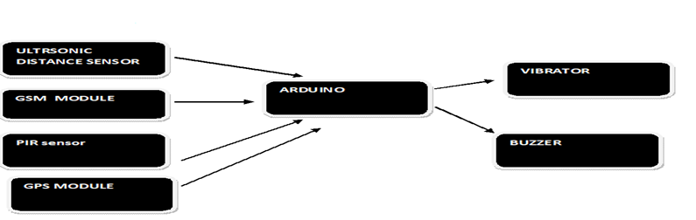

Figure 1. Block diagram of system

Arduino microcontroller is a key feature of this computer. Some of the blocks connected to this device include buzzer, vibrator and ultrasonic sensor screen for barriers (if any) used in this program shown in “Fig”-1. The ultrasonic sensor can provide an inexpensive measuring device. The vibrator and buzzer operate using sensor data.. When a broadcast is found, the buzzer is triggered. Even moving the vibrator to show obstacles. The program has one advantage as well. A blind person may sometimes lose his stone, or he may forget where he was placed. So far, including the GSM and GPS module so that one can track the person in emergency. An PIR module is an electronic device that detects the temperature of a person who passes through the stick due to COVID-19.

## Simulation

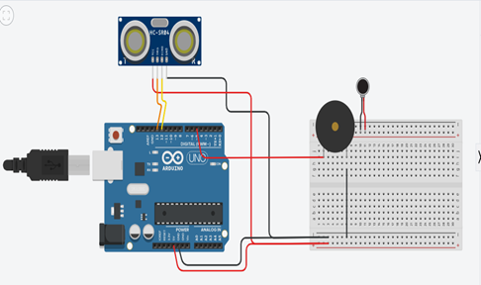

Figure 2 simulation of system on software

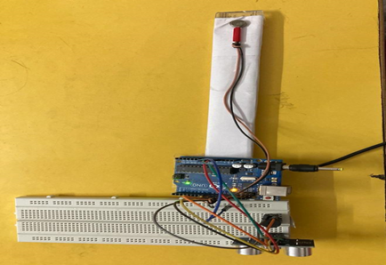

Figure 3. live hands on

## GSM Module

A GSM modem or GSM module is a hardware unit that provides a data link to a remote network using GSM mobile telecommunications technology. In “FIG” -4 practically similar, from the point of view of the cell phone network, to the regular mobile phone, despite the need for a SIM to distinguish the network itself.

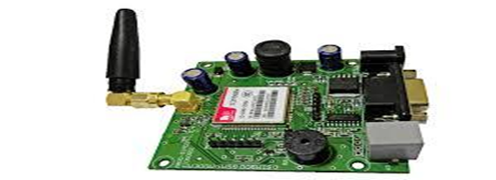

Figure 4 used for sending alert via message

## GPS Module

In order to compute location and time virtually everywhere on earth, GPS receivers use a constellation of satellites and ground stations. . A land based receiver or GPS module can measure its location and time with this knowledge and some math. Shown in figure 5.

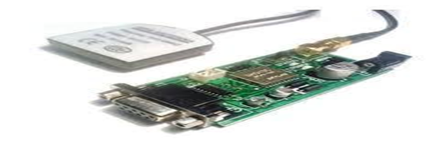

Figure 5. Used For Sending Location To Track

## Ultrasonic Distance Sensor

An ultrasonic sensor “FIG”-6 is a system that can use sound waves to determine the distance from an object. The terminology used to describe elastic waves with a frequency greater than 20,000 Hz and usually found in solids, liquids, and gases are ultrasound waves or ultrasonic waves. At a velocity (wave velocity) defined by the material characteristics and form of the medium, an ultrasonic wave travels.

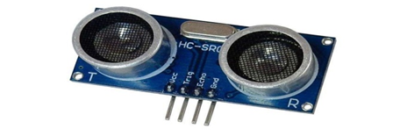

Figure 6. Ultasonic Distance Sensor to Detect Obstacle

## Buzzer

The Piezo buzzer “FIG”-7 generates sound on the basis of the piezoelectric reverse effect. The underlying theory is the creation of pressure variance or strain by the application of electric potential over a piezoelectric substrate. It is possible to use these buzzers to warn a user of an event counter signal or sensor input. This are often found in warning circuits. Regardless of the voltage difference applied to it, the buzzer generates the same disruptive signal.

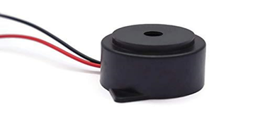

Figure 7. Buzzer For Alert

## Vibration Motor

Vibration motor “FIG”-8 is a coreless DC motor of compact size used to warn users by vibrating, no sound, of receiving the signal. In a range of uses, including mobile phones, handsets, pagers, and so on, vibration motors are commonly used. The main characteristics of the vibration motor are the permanent magnet coreless DC motor, which ensures that it will still have the magnetic properties. Another key advantage is that the motor size itself is compact and thus lightweight.

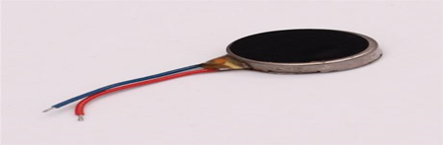

Figure 8. Vibration With Buzzer Alert

## Arduino UNO

Arduino “FIG”-9 is an open-source (prototype) framework focused on easy-to-use hardware and software. It comprises of a programmable circuit board (known as a microcontroller) and a ready-made device named Arduino IDE (Integrated Programming Environment) that is used to write and upload the physical board's computer code.

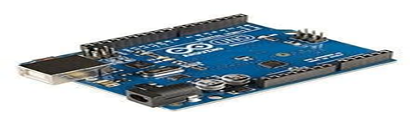

Figure 9. Pin of Ardiuno Mega

## PIR Sensor

A passive infrared sensor (PIR sensor) “FIG”-10 is an electronic sensor that detects the radiation of infrared (IR) light in its field of view from objects. By measuring infrared radiation (radiant heat) produced by or reflected from objects, they function entirely.

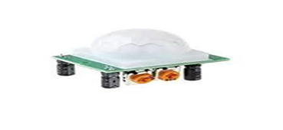

Figure 10. Sensor to Detect Temperature

# Results and Discussion

To have a constructive assistant as shown in “FIG”-11 and help the blind and visually impaired, a convenient, inexpensive, adjustable, easy-to-manage electronic device is suggested. The structure has been developed, enforced, tested, and checked. The program's real-time findings are encouraging; 93 percent consistency in receiving grades has been announced. The findings indicate that the device performs well and is exceptional in its ability to identify the source and distance of objects that could be in contact with the blind. It was also popular with those in the trial who participated. The system is very beneficial in situation like COVID -19 as it is capable of detecting temperature of person who passes via the range of the stick . Ultrasonic sensor has been used extensively to improve the movement of blind and sighted people in a safe and independent manner.

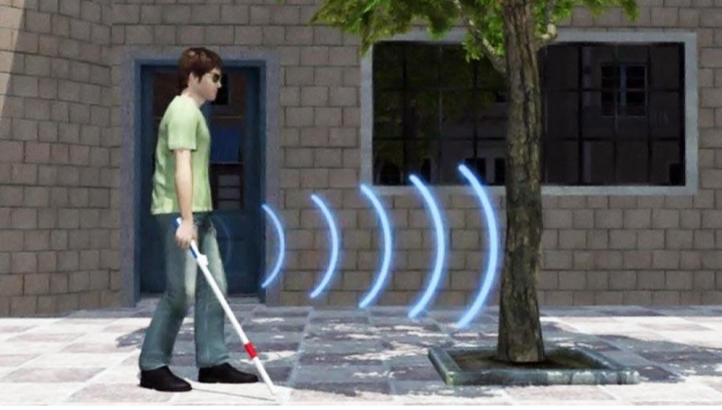

Figure 11 virtual view of system

After looking at the comparison table 1, all the necessary features are embed in this .Our system is 60% more efficient then others .The system detects the obstacle and the stick indicate through vibration and buzzer and if the person is in danger or need help press the button and alert message via GSM module will be send and along with this location of particular person will ne end to the emergency contact to track them.

Table 1. Comparison With Existing Devices

|  |  |  |  |  |  |
| --- | --- | --- | --- | --- | --- |
| Name | Obstacle detection | Alert via  message | Track the location | Temp. Detection (COVID -19) | Vibration and Buzzer |
| Pratik N K (2019) |  |  |  |  |  |
| [Shubham Bele](https://papers.ssrn.com/sol3/cf_dev/AbsByAuth.cfm?per_id=4264662) (2020) |  |  |  |  |  |
| *Amit Thakur (2020)* |  |  |  |  |  |
| *Yashvi Khera &Pawan Whig (2021)* |  |  |  |  |  |

# Conclusion

Finally, the blind walking stick has been turned into a device that can be used to direct the blind. A smart, carefully built walking stick can allow the blind without the help of someone to get from one position to another. It can also be used as an unclean way of supplying the blind with hearing. This rod eliminates visually disabled individuals' reliance on other family members, friends, and guide dogs while walking.. The smart stick senses objects or barriers in front of users and sends an alarm back, vibration also offers warnings and location monitoring. The advantages of this devices are that it may be a cost-effective alternative for millions of blind people around the world.

##### References

1. Sylvain Cardin, Daniel Thalmann and Frederic Vexo, Wearable Obstacle Detection System for visually impaired people, Cole Polytechnique Fédérale de Lausanne (EPFL)CH-1015 Lausanne, Switzerland: Virtual Reality Laboratory (VRlab).
2. Osama Bader AL-Barrm International Journal of Latest Trends in Engineering and Technology (IJLTET).
3. B. Mohan and M. Sitaramaiah, Naganaik-International Journal of Advanced Technology in Engineering and Science, vol. 03, no. 01, January 2015, ISSN 2348-75501q.
4. F. van der Heijden and P.P.L. Regtien, "Wearable navigation assistance - a tool for the blind", MEASUREMENT SCIENCE REVIEW, vol. 5, 2005.
5. Ankit Agarwal, Deepak Kumar and Abhishek Bhardwaj, International Journal Of Engineering And Computer Science, vol. 4, no. 4, pp. 11375-11378, April 2015, ISSN 2319-7242.
6. Divya Srirama, B. Navya, P. Suma Manasa and S. Chitra, Ultrasonic and Voice Based Walking Stick for The Blind Bachelor Degree Gokaraju Rangaraju, Hyderabad:Institute Of Engineering And Technology, 2010.
7. Jayant Sakhardande, Pratik Pattanayak and Mita Bhowmick, "Arduino Based Mobility Cane", International Journal of Scientific &Engineering Research, vol. 4, no. 4, pp. 1163-1166, April 2013.
8. Raymond S. Frenkel, Coded Pulse Transmission and Correlation for Robust Ultrasound Ranging from a Long-Cane Platform, February 2014.
9. Pawan Whig and S. N. Ahmad, Development of Economical ASIC For PCS For Water Quality Monitoring ,Journal of Circuit System and Computers, Vol. 23, No. 6 , 2014, pp: 1-13. ISSN: 0218-1266 (SCI, ISI index).
10. Pawan Whig and S. N Ahmad, “CMOS Integrated VDBA-ISFET Device for Water Quality Monitoring, International journal of intelligent engineering and systems, accepted for publication 2014,Vol.7, No.1,2014. (Scopus) ISSN: 2185-3118.
11. Pawan Whig and Vaibhav Bhatia,” Performance Analysis of Multi-Functional Bot System Design Using Microcontroller” International Journal of Intelligent Systems and Applications,2014 ,02 pp 69-75.ISSN No: 2074-9058.
12. Pawan Whig and S. N. Ahmad, “Development of Low Power Dynamic Threshold PCS System”, Journal of Electrical and Electronic Systems,2014, Vol. 3, Issue3, pp. 1-6. ISSN No:2332-0796.
13. Pawan Whig and S. N. Ahmad, “Novel FGMOS Based PCS Device for Low Power Applications ”,Photonic Sensor(Springer), 2015,Vol.5,Issue 2, pp 1-5.(SCI, ISI Index) ISSN No: 1674-9251.